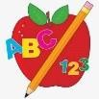 Primary 6 Homework
Week Beginning: 19th January 2026
Here is a guide to help you for this week. You can choose how to organise your tasks to suit what works best for you.

Spelling | Numeracy
Copy your words three times. Then choose an activity from the spelling menu at the back of your jotter.  - Phoneme Words –  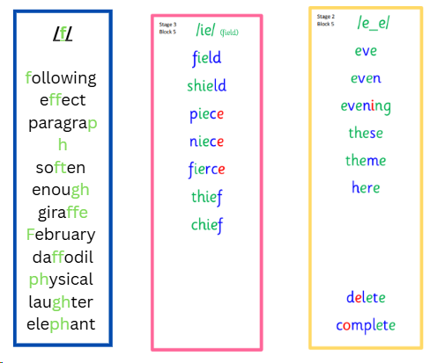  - Common Words –  Group 1 and 2 – Common Words are our topic words (attached below).  Group 3 – practice stage 3 common words (attached below).  Group 4 – practice stage 2 common words (attached below).  Please revise/practise reading and spelling all of the common words for your group. This will be a huge help for all of your reading and spelling. | Multiplication Master  Please find the link below to practice your multiplication facts for your Multiplication Masters.  Hit the Button - Quick fire maths practise for 6-11 year olds  Fractions , percentages and decimals  Have a go at these Questions: attached below  Find Percentages of Quantities of 25 – Circle, Square, Triangles and Diamonds  Race the Clock – Stars  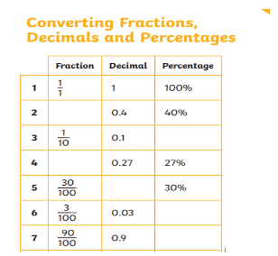  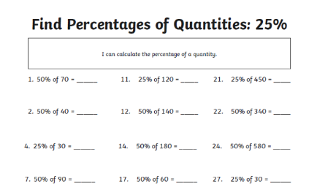  Converting FDP - Circle, Square, Triangles  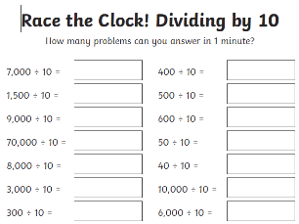
 | Reading
- Your child will get their book home to practise every Monday.
- We will also be practising and completing activities in class so please remember to have their book in their bag every day.


 | PE
P.E. is every Monday and Friday.
Please provide your child with a change of clothing and footwear as well as removing all piercings. If your child has any stud earrings that they can’t
remove, with written permission, we can use plasters to cover them on gym days. Remember your child can leave their PE kit in school which will be kept safely in the classroom.

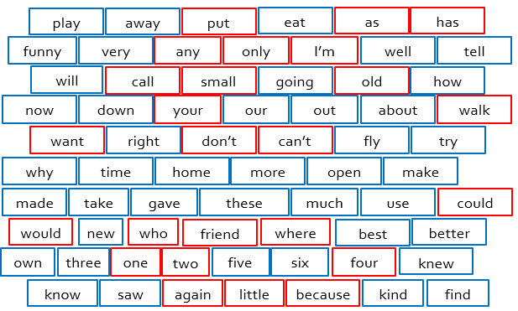
Stage 2

Stage 3
