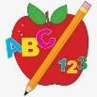 Primary 6 Homework 

**Week Beginning: 6th October 2025**

Here is a guide to help you for this week. You can choose how to organise your tasks to suit what works best for you.

|  |  |
| --- | --- |
| **Spelling** | **Numeracy** |
| Copy your words three times. Then choose an activity from the spelling menu at the back of your jotter.   * Phoneme Words –      * Common Words –   **Group 1 and 2** – Common Words are our topic words (attached below).  **Group 3 and 4** – practice stage 3 common words (attached below).  **Group 5** – practice stage 2 common words (attached below).  Please revise/practise reading and spelling all of the common words for your group. This will be a huge help for all of your reading and spelling. | **Multiplication Master**  Please find the link below to practice your multiplication facts for your Multiplication Masters.  [Hit the Button - Quick fire maths practise for 6-11 year olds](https://www.topmarks.co.uk/maths-games/hit-the-button)  **Rounding**  We have been learning about different strategies to use for addition.  Test your knowledge using the games below. Or you can make up your own sums. Using any 3- or 4-digit numbers making an addition calculation.  [Addition and Subtraction - Mathsframe](https://mathsframe.co.uk/en/resources/category/9/addition-and-subtraction) (Games)  [addition - Topmarks Search](https://www.topmarks.co.uk/Search.aspx?q=addition) |
| **Reading** |
| * Your child will get their book home to practise every Monday. * We will also be practising and completing activities in class so please remember to have their book in their bag every day. |
| **PE** |
| **P.E. is every Monday and Friday.**  Please provide your child with a change of clothing and footwear as well as removing all piercings. **If your child has any stud earrings that they can’t**  **remove, with written permission, we can use plasters to cover them on gym days**. Remember your child can leave their PE kit in school which will be kept safely in the classroom. |

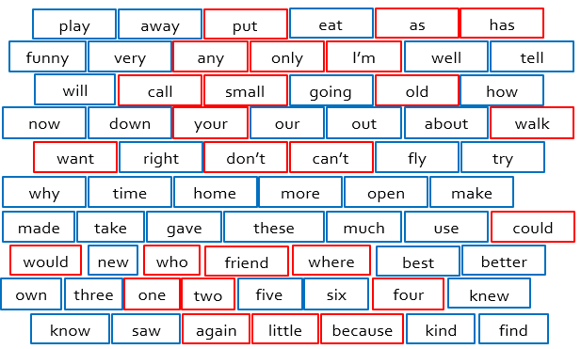

Stage 2

Stage 3

Topic Words

