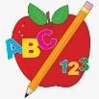 Primary 6 Homework 

**Week Beginning: 15th September 2025**

Here is a guide to help you for this week. You can choose how to organise your tasks to suit what works best for you.

|  |  |
| --- | --- |
| **Spelling** | **Numeracy** |
| Copy your words three times. Then choose an activity from the spelling menu at the back of your jotter.   * Phoneme Words –      * Common Words –   **Group 1 and 2** – Common Words are our topic words (attached below).  **Group 3 and 4** – practice stage 3 common words (attached below).  **Group 5** – practice stage 2 common words (attached below).  Please revise/practise reading and spelling all of the common words for your group. This will be a huge help for all of your reading and spelling.. | **Multiplication Master**  Please find the link below to practice your multiplication facts for your Multiplication Masters.  [Hit the Button - Quick fire maths practise for 6-11 year olds](https://www.topmarks.co.uk/maths-games/hit-the-button)  **Place Value**  We are reviewing our knowledge of place value. Here are some games to try and test what you know!  <https://ictgames.com/mobilePage/placeValue.html> |
| **Reading** |
| * Your child will get their book home to practise every Monday. * We will also be practising and completing activities in class so please remember to have their book in their bag every day. |
| **PE** |
| **P.E. is every Monday and Friday.**  Please provide your child with a change of clothing and footwear as well as removing all piercings. **If your child has any stud earrings that they can’t**  **remove, with written permission, we can use plasters to cover them on gym days**. Remember your child can leave their PE kit in school which will be kept safely in the classroom. |

Stage 2

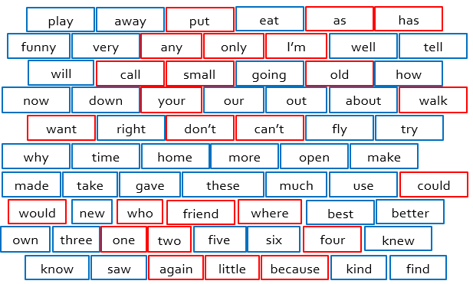

Stage 3

Topic Words

