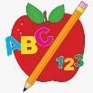 Primary 6 Homework 

**Week Beginning: 15th September 2025**

Here is a guide to help you for this week. You can choose how to organise your tasks to suit what works best for you.

|  |  |
| --- | --- |
| **Spelling** | **Numeracy** |
| Copy your words three times. Then choose an activity from the spelling menu at the back of your jotter.   * Phoneme Words –  |  |  |  |  | | --- | --- | --- | --- | | Group 1 & 2 | Group 3 | Group 4 | Group 5 | | Beginning  Believe  Business  Bubbly  February  Library  Breath  Beautiful  Birthday  Cupboard | Because  Beautiful  Below  Birthday  Grabbed  Rubbish  Beginning  February  Breath  Buy | All  Call  Fall  Tall  Hall  Ball  Mall  Talk  Also  Always  Small | Owl  How  Now  Bow  Cow  Row  down |  * Common Words –   Please revise/practise reading and spelling all of the common words from Stages 2 and 3 (attached below). This will be a huge help for all of your reading and spelling. | **Multiplication Master**  Please find the link below to practice your multiplication facts for your Multiplication Masters.  [Hit the Button - Quick fire maths practise for 6-11 year olds](https://www.topmarks.co.uk/maths-games/hit-the-button)  **Place Value**  We are reviewing our knowledge of place value. Here are some games to try and test what you know!  <https://ictgames.com/mobilePage/placeValue.html> |
| **Reading** |
| * Your child will get their book home to practise every Monday. * We will also be practising and completing activities in class so please remember to have their book in their bag every day. |
| **PE** |
| **P.E. is every Monday and Friday.**  Please provide your child with a change of clothing and footwear as well as removing all piercings. **If your child has any stud earrings that they can’t**  **remove, with written permission, we can use plasters to cover them on gym days**. Remember your child can leave their PE kit in school which will be kept safely in the classroom. |

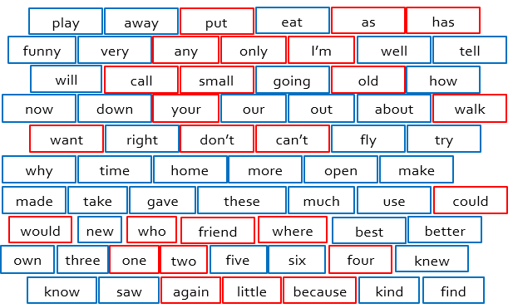

Stage 2

Stage 3

