P3/4 Homework
Week Beginning 4th March 2024
Homework will be collected on a Thursday. Pease make sure that your children bring their reading books to school daily as we will be reading in class.

Homework Task
Spelling Words

Copy out your spelling words neatly one time. Pick 4 words and draw a picture for them.

Twirls and M&Ms​ | Crunchies​ | Reece's Pieces​
1.shouted​ | 1.break​ | 1.right​
2. shoe​ | 2. steak​ | 2. slight​
3. lotion​ | 3. great​ | 3. might​
4. potion​ | 4. breakfast​ | 4. fright​
5. quiche​ | 5. bear ​ | 5. frighten​
6. crochet​ | 6. pear​ | 6. light ​
7. mansion​ | 7. wear​ | 7. alright ​
8. pension​ | 8. tear​ | 8. lighter​
9. emotion​ | 9. ​ | 9. lightest​
10. shower​ | 10.​ | 10. slightest​

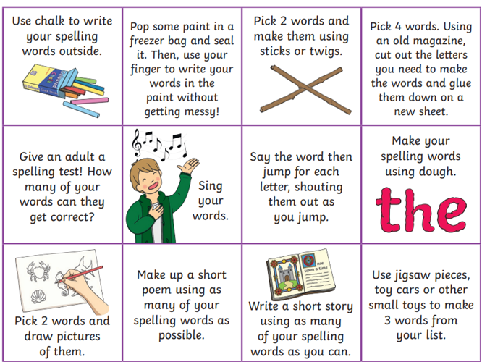
As an extra challenge, pick one task from the spelling grid to do as well.
Please ensure that you are reading and going over common words, they are kept in a small tub in your child’s folder.

Common Words

Twirls & M&Ms​ | Crunchies​ | Reece's Pieces​
sure​ | white​ | who ​
before​ | why​ | after​
never​ | also​ | and​
fruit​ | great​ | right​

Reading

The Twirls | M&Ms | The Crunchies | Reece’s Pieces
How to be an Explorer | Unexpected! | Tricking Our Eyes | Nowhere to Go!

Numeracy  For numeracy we are working on division, have a go at these games to show off your skills. Please also encourage your children to practice times tables as often as possible.  Coconut Multiples Coconut Multiples - Reinforce Times Tables (topmarks.co.uk) Demolition Division https://www.arcademics.com/games/demolition | Please also use these different QR codes to practice times tables.  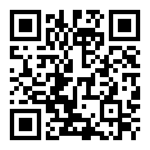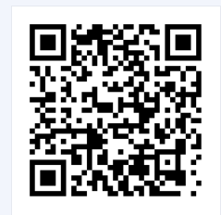  interactive times tables | multiplication square | whiteboard | fish | visnos
Notes
P.E. is every Monday and Friday. Please provide your children with a change of clothing and footwear as well as removing all piercings on the day.

