P3/4 Homework
Week Beginning: 22nd January 2024
Homework will be collected on a Thursday. Pease make sure that your children bring their reading books to school daily as we will be reading in class.

Over the next few weeks part of your child’s homework will be to learn their own Scots poem. The children have a paper copy in their bags as well as a copy below.

Scots Poem – Street Talk by J. K. Annand
There was a rammie in the street,
A stishie and stramash.
The crabbit wifie up the stair
Pit up her winda sash.
“Nou what’s adae?” the wifie cried,
“Juist tell me what’s adae.”
A day is twinty-fower hours, missis,
Nou gie us peace to play.
“Juist tell me what’s ado,” she cried,
“And nane o yer gab,” cried she.
D’ye no ken a doo’s a pigeon, missis?
Nou haud your wheesht a wee.
“I want to ken what’s up,” she cried,
“And nae mair o yer cheek, ye loun.”
It’s only yer winda that’s up, missis.
For guidsake pit it doun.

Homework Task
Spelling Words
Twirls and M&Ms​ | Crunchies​ | Reece's Pieces​
1.moist​ | 1.supplied​ | 1.grew​
2. hoist​ | 2. tie​ | 2. stew​
3. spoilsport​ | 3. died​ | 3. few​
4. rejoin​ | 4. fried​ | 4. blew​
5. poison​ | 5. have​ | 5. new​
6. enjoyment​ | 6. give​ | 6. maul​
7. destroy ​ | 7. love​ | 7. vault​
8. employ ​ | 8. gentle​ | 8. Paul​
9. alloy​ | 9. gem​ | 9. because​
10. oyster​ | 10. gym​ | 10. haunt​

Please read over your spelling words, ensuring you are practicing your new sound.

As an extra challenge, pick one task from the spelling grid to do as well.
Please ensure that you are reading and going over common words, they are kept in a small tub in your child’s folder.

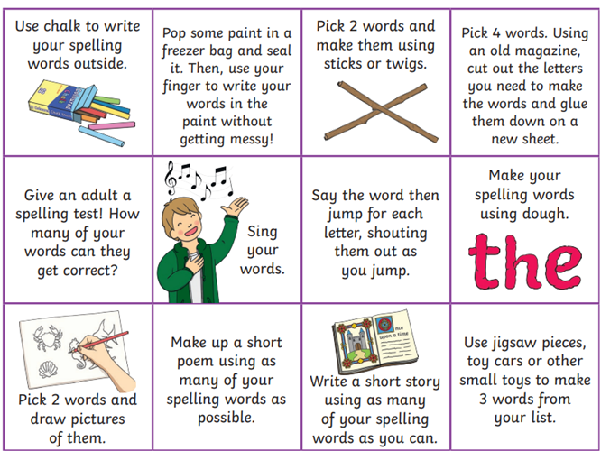

Common Words

Twirls & M&Ms​ | Crunchies​ | Reece's Pieces​
January ​ | around​ | because​
February​ | something​ | what​
March​ | live​ | many​
April​ | small​ | when​
May​ | hour​

Reading
The Twirls | M&Ms | The Crunchies | Reece’s Pieces
Haunting Histories | Likety Kwick and the Mixed-Up Fix | Everyone Loves King Julien! | Bug Boy Spider Camp

Numeracy  For numeracy we are working on multiplication, have a go at these addition games to show off your skills.  Coconut Multiples Coconut Multiples - Reinforce Times Tables (topmarks.co.uk) Bowling Multiplication Super Maths Bowling - Multiplication - Mathsframe | Please also use these different QR codes to practice times tables.  interactive times tables | multiplication square | whiteboard | fish | visnos
Notes
P.E. is every Monday and Friday. Please provide your children with a change of clothing and footwear as well as removing all piercings on the day.

