P3/4 Homework
Week Beginning: 20th November 2023
Homework will be collected on a Thursday. Pease make sure that your children bring their reading books to school daily as we will be reading in class.
Homework Task
Spelling Words

Rainbow write your spelling words 2 times. Can you come up with any words that rhyme with your spelling and common words?

As an extra challenge, pick one task from the spelling grid to do as well.
Please ensure that you are reading and going over common words, they are kept in a small tub in your child’s folder.

Twirls and M&Ms​ | Crunchies​ | Reece's Pieces​
1.shook​ | 1.then​ | 1.blue​
2. proof​ | 2. this ​ | 2. clue​
3. prune ​ | 3. there​ | 3. true​
4. cute​ | 4. them ​ | 4. glue​
5. flew​ | 5. these​ | 5. Sue​
6. blew​ | 6. father​ | 6. due​
7. clue​ | 7. mother​ | 7. venue​
8. glue​ | 8. brother​ | 8. rescue​
9. put​ | 9. rather​ | 9. value​
10. pull​ | 10. gather​ | 10. argue​

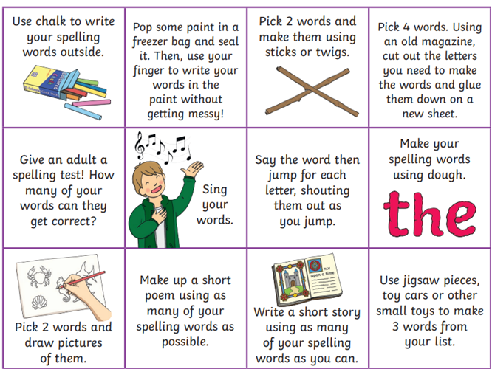

Common Words

Twirls / M&Ms​​ | Crunchies​​ | Reece's Pieces​​
difficult​ | spring​ | blue​
little​ | sunny​ | best​
Scotland​ | those​ | number​
England​ | home​ | other​

Reading
The Twirls | M&Ms | The Crunchies | Reece’s Pieces
How Do They Make Costumes? | Animal Self-defence | The Old Things | My Pony Book

Numeracy  For numeracy we are working on subtraction, have a go at these addition games to show off your skills.  Number bonds – pick subtraction https://www.topmarks.co.uk/maths-games/hit-the-button Number Fact Families https://www.topmarks.co.uk/number-facts/number-fact-families | Please also use these different QR codes to practice times tables.  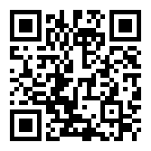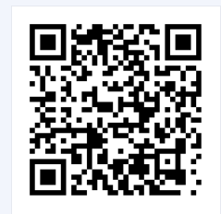  interactive times tables | multiplication square | whiteboard | fish | visnos
Notes
P.E. is every Monday and Friday. Please provide your children with a change of clothing and footwear as well as removing all piercings on the day.

