P3/4 Homework
Week Beginning: 9th October 2023
Homework will be collected on a Thursday. Pease make sure that your children bring their reading books to school daily as we will be reading in class.
Homework Task
Spelling Words

Rainbow write your spelling words 2 times.
As an extra challenge, pick one task from the spelling grid to do as well.
Please ensure that you are reading and going over common words, they are kept in an envelope in your child’s folder.

Twirls and M&Ms | Crunchies | Reece's Pieces
1.between | 1.came | 1.muck
2. feelings | 2. take | 2. pluck
3. cheat | 3. gave | 3. maid
4. speak | 4. cute | 4. raid
5. he | 5. huge | 5. enjoy
6. she | 6. rude | 6. toy
7. thief | 7. seat | 7. toad
8. mischief | 8. read | 8. moan
9. complete | 9. team | 9. quiz
10. evening | 10. speak | 10. quit

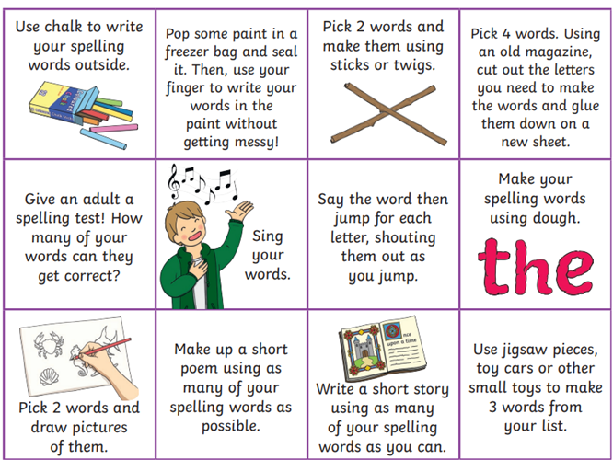

Common Words

Twirls / M&Ms​ | Crunchies​ | Reece's Pieces​
football | each | your
group | year | before
holiday | away | of
I’m | always | are

Reading
The Twirls | M&Ms | The Crunchies | Reece’s Pieces
Weird Weather | Flint the Inventor | Fight the Flames | Growing Food

Numeracy  Please try to revise some of our place value and rounding that we have been working on as a class with the games on the QR codes.  Addition Alien addition  20  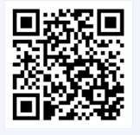  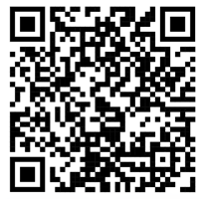 | Please also use these different QR codes to practice times tables.  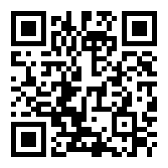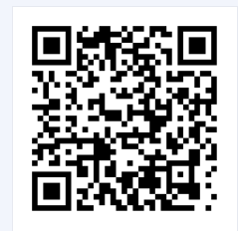  interactive times tables | multiplication square | whiteboard | fish | visnos
Notes
P.E. is every Monday and Friday. Please provide your children with a change of clothing and footwear as well as removing all piercings on the day.

