P3/4 Homework
Week Beginning: 2nd October 2023
Homework will be collected on a Thursday. Pease make sure that your children bring their reading books to school daily as we will be reading in class.
Homework Task
Spelling Words
Copy your spelling words 3 times into your homework jotter.
As an extra challenge, pick one task from the spelling grid to do as well.
Please ensure that you are reading and going over common words, they are kept in an envelope in your child’s folder.

Twirls and M&Ms​​ | Crunchies​​ | Reece's Pieces​​
1.indeed​​ | 1.bike​​ | 1.​ brain ​
2. agree​​ | 2. five​​ | 2.​chair​
3. please​​ | 3. hide​​ | 3.​ pick​
4. leave​​ | 4. beside​​ | 4.​ bucket​
5. me​​ | 5.home​​ | 5.​ enjoy​
6. we​​ | 6. phone​​ | 6.​ boy​
7. believe​​ | 7. before​​ | 7.​ road​
8. piece​​ | 8. here​​ | 8. ​boat​
9. these​​ | 9. evening​​ | 9.​ quick​
10. here​​ | 10. complete​​ | 10.​ queen​

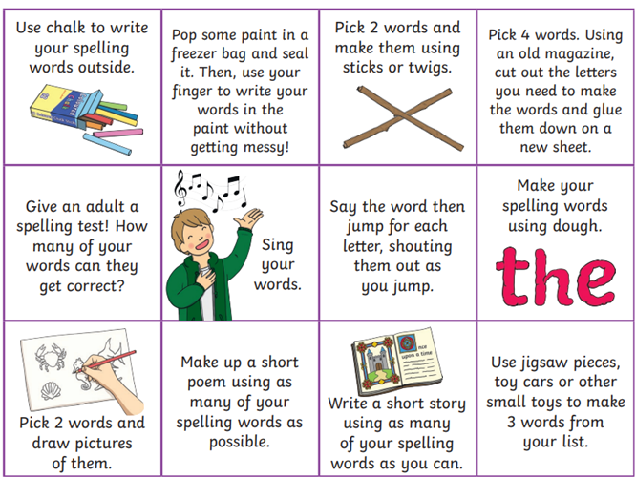

Common Words

Twirls / M&Ms​ | Crunchies​ | Reece's Pieces​
accident​ | know​ | have​
below​ | yellow​ | come​
cloudy​ | father​ | said​
eleven​ | mother​ | could​

Reading
The Twirls | M&Ms | The Crunchies | Reece’s Pieces
Going into Space | Fossils | What Makes You Laugh? | Shadows in the Sun

Numeracy  Please try to revise some of our place value and rounding that we have been working on as a class with the games on the QR codes.  Daily 10 challenges  Place value basketball  Place value basketball  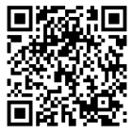  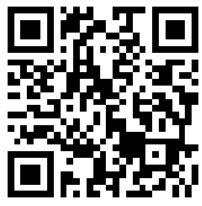  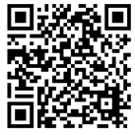 | Please also use these different QR codes to practice times tables.  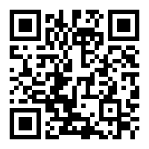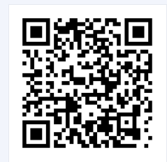  interactive times tables | multiplication square | whiteboard | fish | visnos
Notes
P.E. is every Monday and Friday. Please provide your children with a change of clothing and footwear as well as removing all piercings on the day.

