P3/4 Homework
Week Beginning: 25th September 2023
Homework will be collected on a Thursday. Pease make sure that your children bring their reading books to school daily as we will be reading in class.
Homework Task
Spelling Words
As last week and this week are shorter weeks, we are keeping the same spelling words for homework. Please complete the spelling wordsearch challenge for this week.
As an extra challenge, pick one task from the spelling grid to do as well!
Please ensure that you are reading and going over common words, they are kept in an envelope in your child’s folder.

Twirls and M&Ms | Crunchies | Reece’s Pieces
^{1.table} | ^{1.around} | ^{1.back}
^{2. amazed} | ^{2. thousand} | ^{2. rocket}
^{3. yesterday} | ^{3. count} | ^{3. chair}
^{4. play} | ^{4. slight} | ^{4. brain}
^{5. complain} | ^{5. might} | ^{5. enjoy}
^{6. paid} | ^{6. right} | ^{6. toy}
^{7. turkey} | ^{7. why} | ^{7. float}
^{8. chimney} | ^{8. cry} | ^{8. road}
^{9. steak} | ^{9. shy} | ^{9. quick}
^{10. great} | ^{10. myself} | ^{10. queen}

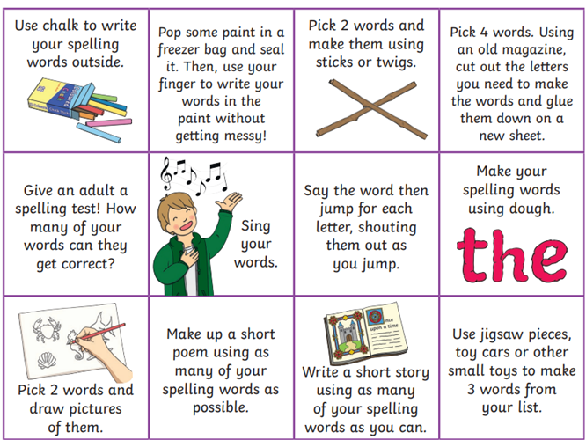

Common Words
Twirls and M&Ms | Crunchies | Reece’s Pieces
^{million} | ^{too} | ^{said}
^{surprise} | ^{school} | ^{could}
^{care} | ^{some} | ^{her}
^{busy} | ^{never} | ^{before}

Reading
The Twirls | M&Ms | The Crunchies | Reece’s Pieces
I Want a Unicorn! | I Want a Unicorn! | Can We Keep him? | Animal Babies

Numeracy  Please have a go at working on subtracting as this is something that we have been working on as a class.  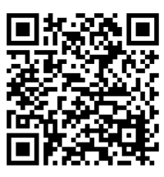 | Please also use these different QR codes to practice times tables.  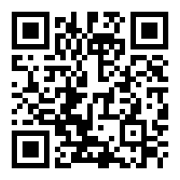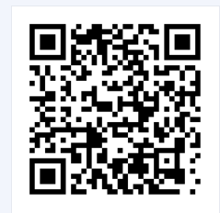  interactive times tables | multiplication square | whiteboard | fish | visnos
Notes
P.E. is every Monday and Friday. Please provide your children with a change of clothing and footwear as well as removing all piercings on the day.

