P3/4 Homework
Week Beginning: 18th September 2023
Homework will be collected on a Thursday. Pease make sure that your children bring their reading books to school daily as we will be reading in class.

Homework Task
Spelling Words
Rainbow write your spelling words two more times, then pick three spelling words and draw a picture for them.
As an extra challenge, pick one task from the spelling grid to do as well!
Please also ensure that you are reading and going over common words, they are kept in an envelope in your child’s folder.

Twirls and M&Ms | Crunchies | Reece’s Pieces
^{1.table} | ^{1.around} | ^{1.back}
^{2. amazed} | ^{2. thousand} | ^{2. rocket}
^{3. yesterday} | ^{3. count} | ^{3. chair}
^{4. play} | ^{4. slight} | ^{4. brain}
^{5. complain} | ^{5. might} | ^{5. enjoy}
^{6. paid} | ^{6. right} | ^{6. toy}
^{7. turkey} | ^{7. why} | ^{7. float}
^{8. chimney} | ^{8. cry} | ^{8. road}
^{9. steak} | ^{9. shy} | ^{9. quick}
^{10. great} | ^{10. myself} | ^{10. queen}

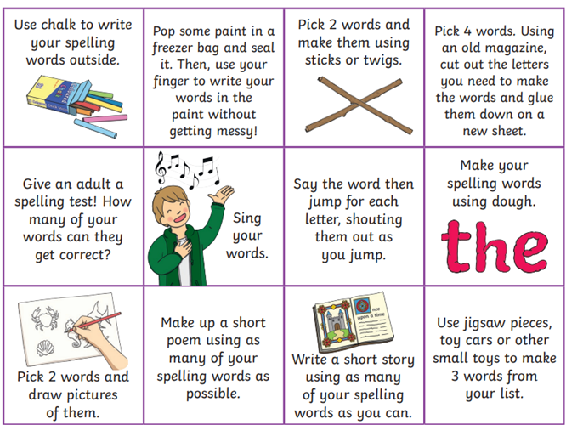
Common Words
Twirls and M&Ms | Crunchies | Reece’s Pieces
^{million} | ^{too} | ^{said}
^{surprise} | ^{school} | ^{could}
^{care} | ^{some} | ^{her}
^{busy} | ^{never} | ^{before}

Reading
The Twirls | M&Ms | The Crunchies | Reece’s Pieces
I Want a Unicorn! | I Want a Unicorn! | Can We Keep him? | Animal Babies

Numeracy  This week we have been working on estimating and rounding, try out this game to show off your skills.  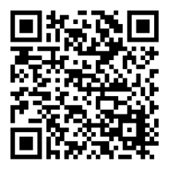 | Please also use these different QR codes to practice times tables.  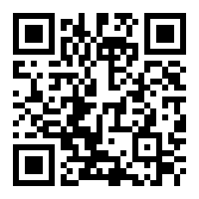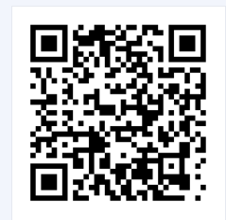  interactive times tables | multiplication square | whiteboard | fish | visnos
Notes
P.E. is every Monday and Friday. Please provide your children with a change of clothing and footwear as well as removing all piercings on the day.

