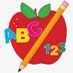 Primary 4 Homework
Week Beginning: 5th October 2026
Here is a guide to help you for this week. You can choose how to organise your tasks to suit what works for you.
Homework will be collected in on a Friday as there will not be any homework at the weekend.
Spelling | Numeracy | Nessy
Please complete 2 active and 2 written spelling activities for your words.  Activities list on blog.  Spelling Lists are below. | Click on the Learning Intention to play the games.  LI – To add and subtract.  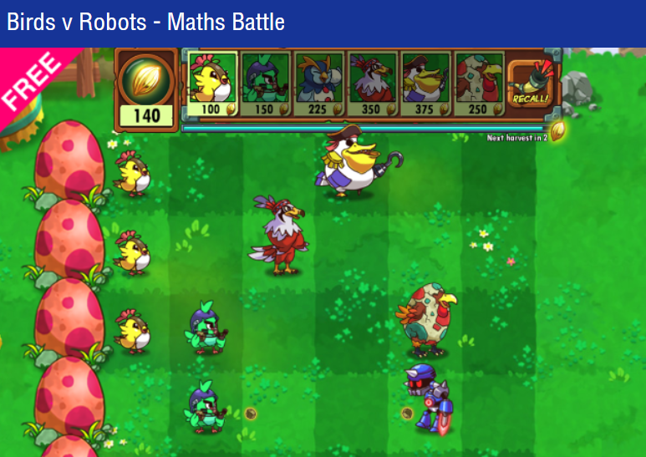 | 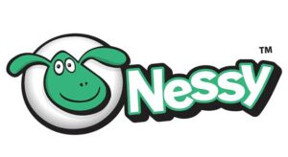  Login to Nessy to complete Numeracy, Literacy and Typing tasks.  Numeracy LI- To be able to develop my accuracy in using the operations.  LI- To be able to develop my typing skills.

Phonemes | Common Words
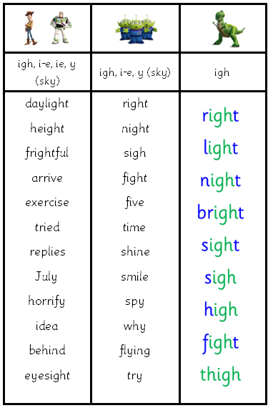
  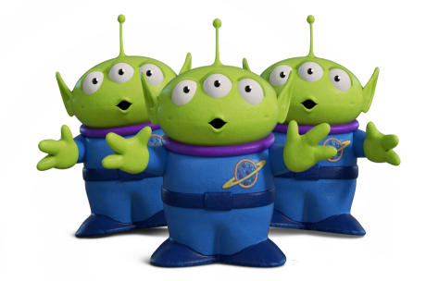 | 
  don’t  can’t  fly | don’t  can’t

