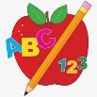 Primary 4 Homework
Week Beginning: 25th May 2026
Here is a guide to help you for this week. You can choose how to organise your tasks to suit what works for you.
Homework will be collected in on a Friday as there will not be any homework at the weekend.
Spelling |  | Reading |  | Numeracy
Please complete 2 active and 2 written spelling activities for your words.  Activities list on blog.  Stage 4  This week we are learning the ‘s’ sound with spellings:  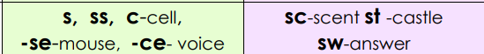  Rex  This week we are learning to spell the ‘ey’ (they) phoneme.  Forky  This week we are learning to spell the ‘ss’ phoneme.  Spelling lists are below. | Enjoy reading your book at home.  Can you spot any of your phoneme words?  Retell the events of the story in order.   |  | Practice your number skills on Nessy Number Sense.    Multiplication  We are learning to practice our times tables.  https://www.timestables.co.uk/  Division  We are learning to divide.  https://mathsframe.co.uk/en/resources/resource/599/Boxy-Bird  Money  We are learning to save and budget.  https://natwestthrive.com/resource-hub/becoming-a-budget-master
Stage 4 | Rex | Forky
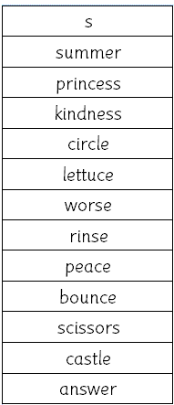 | 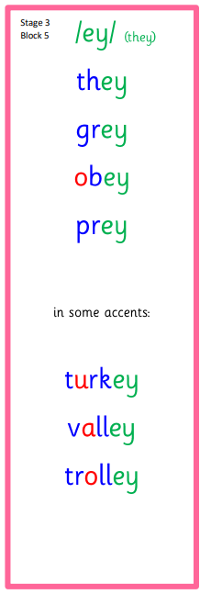  Common Words  they | 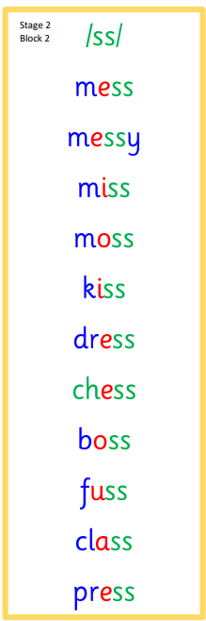  Common Words  I’m

