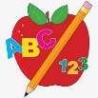 Primary 4 Homework
Week Beginning: 26th January 2026
Here is a guide to help you for this week. You can choose how to organise your tasks to suit what works for you.
Homework will be collected in on a Friday as there will not be any homework at the weekend.
Spelling |  | Reading |  | Numeracy
Please complete 2 active and 2 written spelling activities for your words.  Activities list on blog.  Stage 4  This week we are learning the ‘g’ sound and its different spellings.  Rex  This week we are focusing on spelling with the ‘al’ phoneme.  Forky  This week we are focusing on spelling with the ‘wh’ phoneme.  Spelling lists are below. | Enjoy reading your book at home.  Can you spot any of your phoneme words?    Reading Challenge  Complete the reading challenge cards.  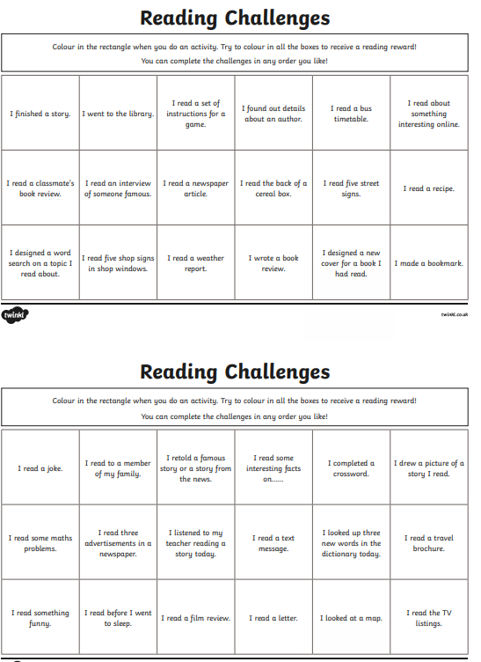 |  | Click on the Learning Intention to play the games.  LI – To multiply.  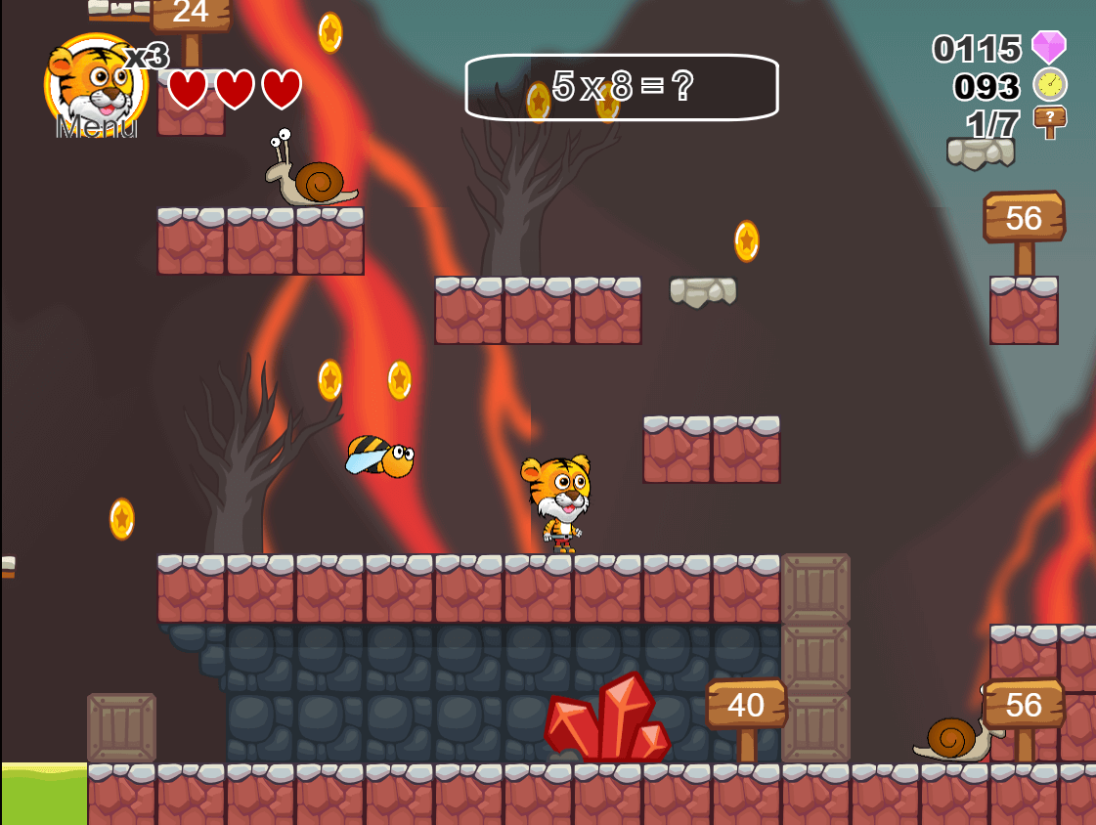  LI – To multiply using the written method.  Level 4  
Stage 4 | Rex | Forky
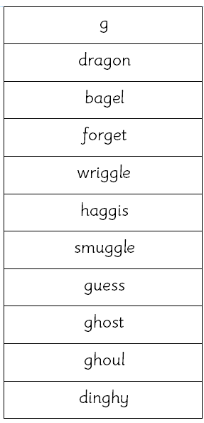 | 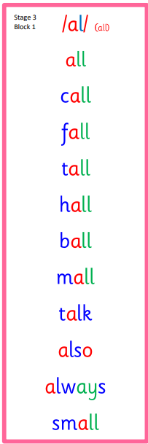  Common Words  call fall  talk also | 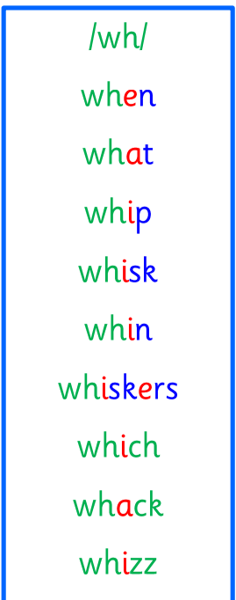  Common Words  when what

