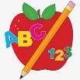 Primary 4 Homework
Week Beginning: 8th December 2025
Here is a guide to help you for this week. You can choose how to organise your tasks to suit what works for you.
Homework will be collected in on a Friday as there will not be any homework at the weekend.
Spelling |  | Reading |  | Numeracy
Please complete 2 active and 2 written spelling activities for your words.  Activities list on blog.  Stage 4  This week we are learning the ‘yoo’ sound and its different spellings.  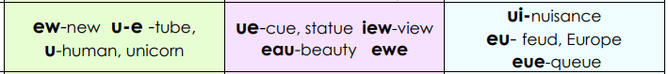  Rex  This week we are learning the ‘g’ (gem) phoneme.  Forky  This week we are learning the ‘y’ phoneme.  Spelling lists are below. | Enjoy reading your book at home.  Can you spot any of your phoneme words?  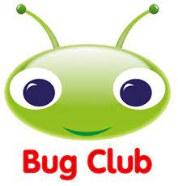 |  | Click on the Learning Intention to play the games.  LI – To add and subtract.  Create your own patterns, tessellations and explore symmetry with different 2D shapes.  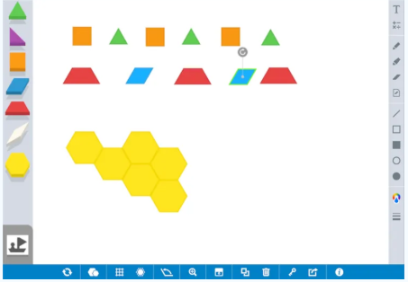
Stage 4 | Rex | Forky
Europe  fewer  New York  confuse  Cuba  human  issue  educate  ewe  tissue  beautiful  popular  queue | 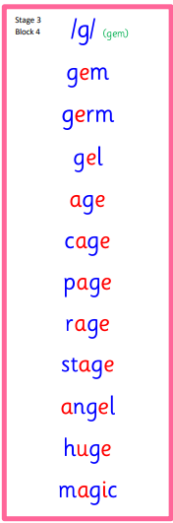  Common Words  didn’t | 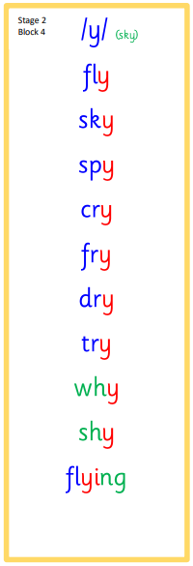  Common Words  fly try why

