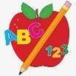 Primary 4 Homework
Week Beginning: 1st December 2025
Here is a guide to help you for this week. You can choose how to organise your tasks to suit what works for you.
Homework will be collected in on a Friday as there will not be any homework at the weekend.
Spelling |  | Reading |  | Numeracy
Please complete 2 active and 2 written spelling activities for your words.  Activities list on blog.  Stage 4  This week we are learning the ‘oo’ sound and its different spellings.  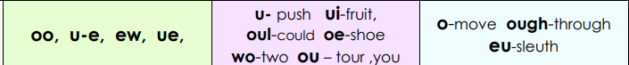  Rex  This week we are learning the ‘c’ sound.  Forky  This week we are learning the ‘igh’ sound.  Spelling lists are below. | Enjoy reading your book at home.  Can you spot any of your phoneme words?   |  | Click on the Learning Intention to play the games.  LI – To add and subtract.  LI – To recognise and sort 3D shapes.  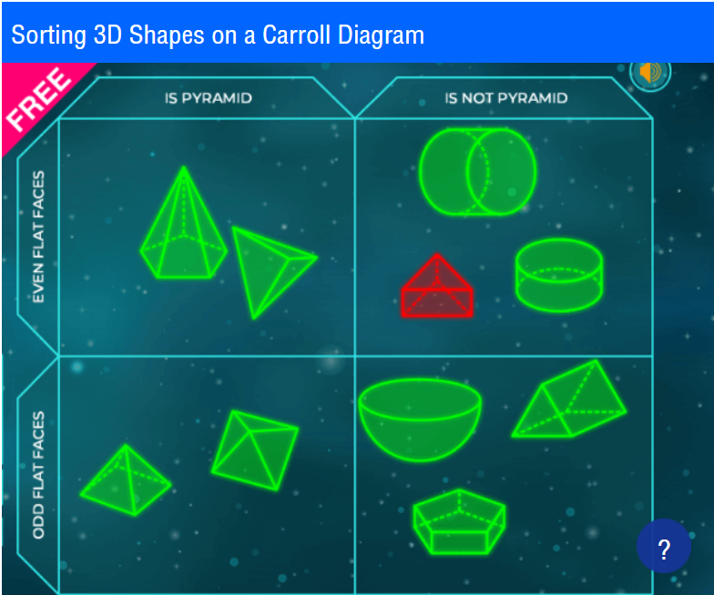
Stage 4 | Rex | Forky
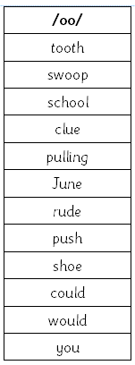 | 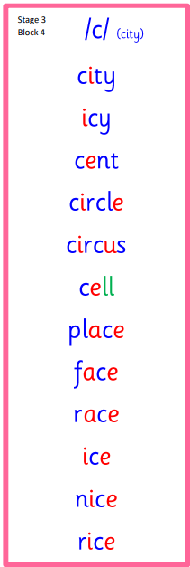  Common Words  place upon  once | 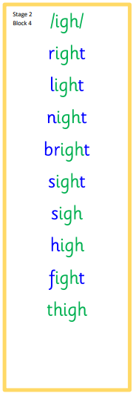  Common Words  right  don’t can’t

