 Primary 4 Homework
Week Beginning: 24th November 2025
Here is a guide to help you for this week. You can choose how to organise your tasks to suit what works for you.
Homework will be collected in on a Friday as there will not be any homework at the weekend.
Spelling |  | Reading |  | Numeracy
Please complete 2 active and 2 written spelling activities for your words.  Activities list on blog.  Stage 4  This week we are learning to spell time words.  Rex  This week we are consolidating ‘tch’ ‘-se’ ‘ve’ phonemes.  Forky  This week we are consolidating the ‘ou’ ‘ow’ ‘oi’ phonemes.  Spelling lists are below. | Enjoy reading your book at home.  Can you spot any of your phoneme words?    Retelling  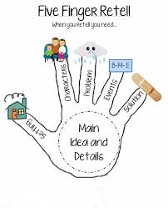  Retell the story of Aladdie (panto) to someone at home. |  | Click on the Learning Intention to play the games.  LI – To add and subtract.  LI – To read and use a timetable.  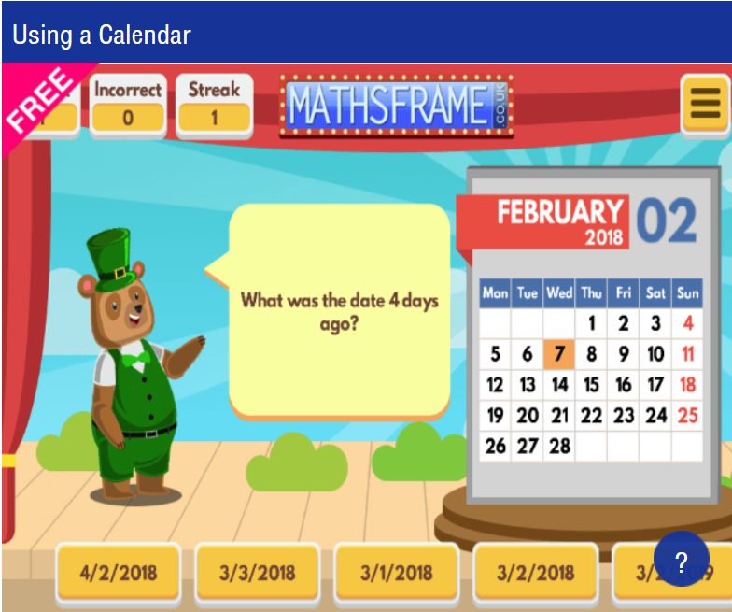
Stage 4 | Rex | Forky
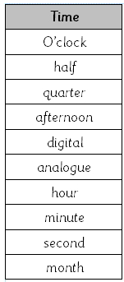 | 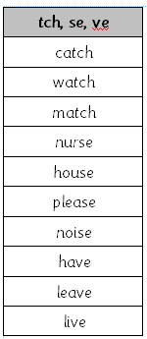 | 