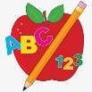 Primary 4 Homework
Week Beginning: 3rd November 2025
Here is a guide to help you for this week. You can choose how to organise your tasks to suit what works for you.
Homework will be collected in on a Friday as there will not be any homework at the weekend.
Spelling |  | Reading |  | Numeracy
Please complete 2 active and 2 written spelling activities for your words.  Activities list on blog.  Stage 4  This week we are learning the ‘i’ sound and its different spellings. 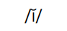  Rex  This week we are learning the ‘-se’ sound.  Forky  This week we are learning the ‘ou’ (out) sound.  Spelling lists are below. | Enjoy reading your book at home.  Can you spot any of your phoneme words?   |  | Click on the Learning Intention to play the games.  LI – To add and subtract.  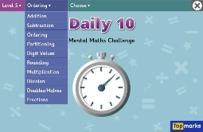  LI – To tell the time.  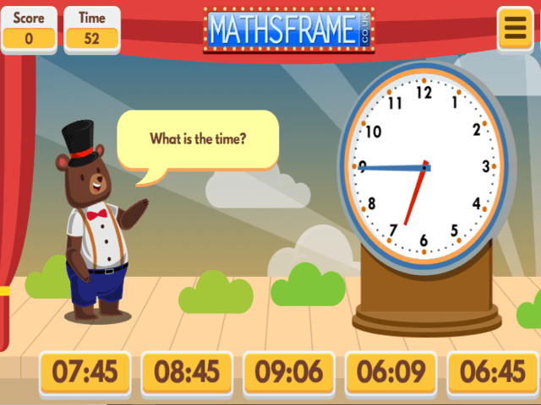

Stage 4 | Rex | Forky
Grinch  Lyndsey  whisk  discovered  marriage  prettiest  village  city  silly  mystery  finish  damage | 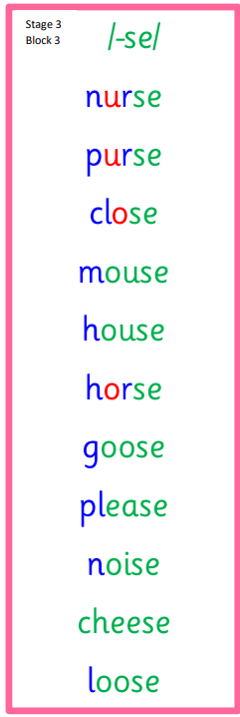  Common Words  please  first girl bird | 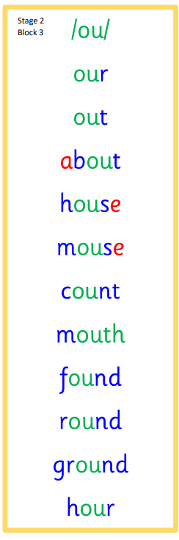  Common Words  our out about

