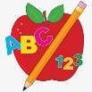 Primary 4 Homework
Week Beginning: 3rd November 2025
Here is a guide to help you for this week. You can choose how to organise your tasks to suit what works for you.
Homework will be collected in on a Friday as there will not be any homework at the weekend.
Spelling |  | Reading |  | Numeracy
Please complete 2 active and 2 written spelling activities for your words.  Activities list on blog.  Stage 4  This week we are learning the ‘ie’ sound and its different spellings.  Rex  This week we are learning the ‘tch’ sound.  Forky  This week we are learning the ‘ow’ (owl) sound.  Spelling lists are below. | Enjoy reading your book at home.  Can you spot any of your phoneme words?    Visualisation  Read the text carefully. What do you imagine this scene might look like?  Draw an image to match the text.  The sky was black, like a big, soft blanket. Suddenly, a bright light shot up, up, up! WHOOSH! It burst high above our heads, making a huge, round flower of red and gold. The shimmering petals sparkled and drifted slowly down.  Another rocket zoomed into the darkness. ZZZZZZZZZ! It exploded into a million tiny, white stars that twinkled and glittered. We all shouted with happy surprise. Then, a giant green ball of light appeared and popped with a deep BOOM! |  | Click on the Learning Intention to play the games.  LI – To practice times tables.  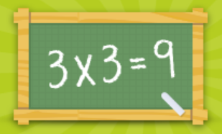  LI – We are learning about grid references and direction.  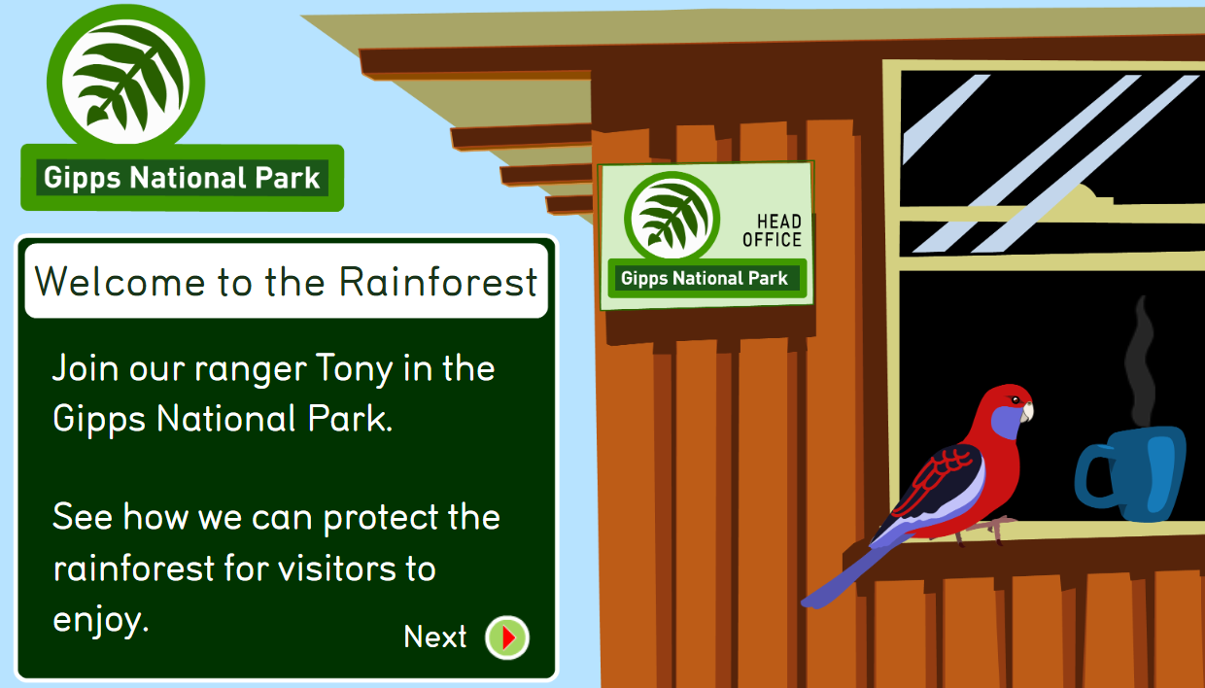  LI – To identify angles.  

Stage 4 | Rex | Forky
pie  cried  decide  slime  bike  light  bright  delight  kind  python  goodbye  Skye  eye | 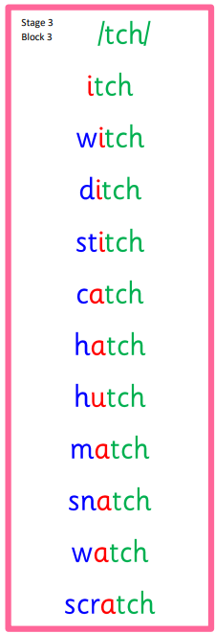  Common Word  watch | 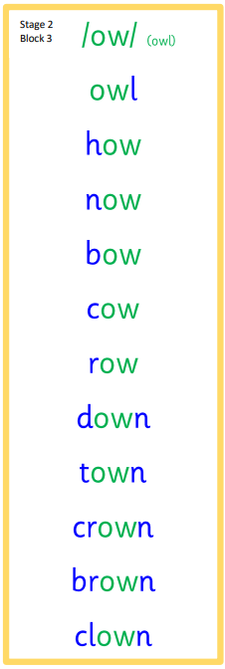  Common Words  how now down  your

