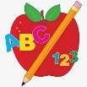 Primary 4 Homework
Week Beginning: 27th October 2025
Here is a guide to help you for this week. You can choose how to organise your tasks to suit what works for you.
Homework will be collected in on a Friday as there will not be any homework at the weekend.
Spelling |  | Reading |  | Numeracy
Please complete 2 active and 2 written spelling activities for your words.  Activities list on blog.  Stage 4  This week we are learning different topical words.  Rex  This week we are consolidating the ‘ea’ (head), ‘ie’ (tried) and ‘u’ (oo and yoo) sound.  Forky  This week we are consolidating the ‘ss’, ‘ll’ and ‘ff’ sound.  Spelling lists are below. | Enjoy reading your book at home.  Can you spot any of your phoneme words?    Visualisation  Read the text carefully. What do you imagine this scene might look like?  Draw an image to match the text.  It was quiet and still in the woods. No birds singing in the trees, no sounds of footsteps through the dirt. They were there though, hiding. Birds and animals of all shapes and sizes, peeking through the branches to see the bright shining object that had just fallen into the clearing. |  | Click on the Learning Intention to play the games.  LI – To practice times tables.  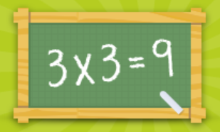  LI – We are learning about grid references and direction.  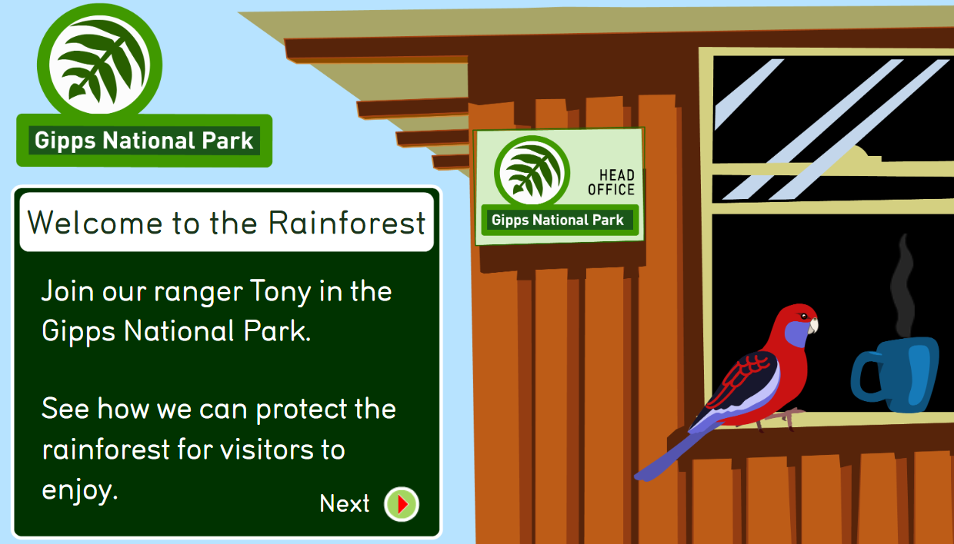

Stage 4 | Rex | Forky
pumpkin  haunted  witch  cauldron  ghost  zombie  skeleton  werewolf  vampire  terrifying  frightening
  ea, ie, u
  head
  health
  weather
  spread
  tie
  fries
  dried
  push
  full
  unit
  music
  ss, ll, ff
  boss
  class
  press
  messy
  well
  hill
  spill
  still
  off
  stuff
  fluff
  staff

