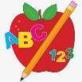 Primary 4 Homework
Week Beginning: 20th October 2025
Here is a guide to help you for this week. You can choose how to organise your tasks to suit what works for you.
Homework will be collected in on a Friday as there will not be any homework at the weekend.
Spelling |  | Reading |  | Numeracy
Please complete 2 active and 2 written spelling activities for your words.  Activities list on blog.  Stage 4  This week we are learning the /ĕ/ sound with spellings ‘e’ ‘ea’ ‘ay’ e-e’ ‘ie’ ‘ai’ ‘a’ ‘ei’ ‘u’ ‘eo’  Rex  This week we are learning the ‘u’ (oo and yoo) sound.  Forky  This week we are learning the ‘ff’ sound.  https://www.bbc.co.uk/bitesize/articles/zrfrgwx  Spelling lists are below. | Enjoy reading your book at home.  Can you spot any of your phoneme words?    Visualisation  Read the text carefully. What do you imagine this scene might look like?  Draw an image to match the text.  I stood at the bottom of an impossibly tall staircase. It sparkled and shone, golden in the bright sunlight, as it curled up and up into the clouds. There was no way to know what might be up there, the clouds thick and fluffy, blocking the view of the top. I took a deep breath and stepped onto the first stair. |  | Click on the Learning Intention to play the games.  LI – To double and half numbers.  LI – To practice number bonds.  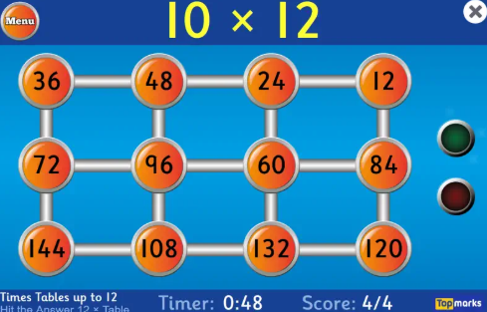  LI – To add and subtract.  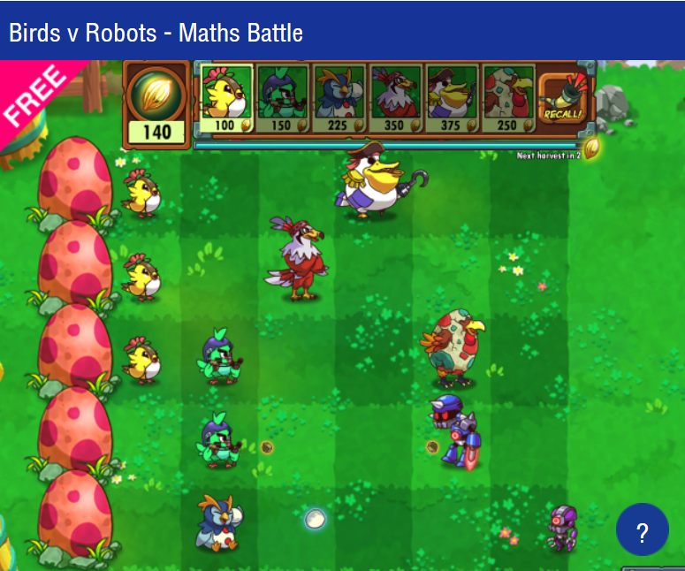

Stage 4 | Rex | Forky
dress  lent  bench  kennel  bread  feather  sweat  were  friend  any  many  Common Words  push  pull  full | push  bush  pull  full  bull  unit  computer  music  human  tulip  Common Words  push  full  pull | off  cuff  puff  puffin  stuff  fluff  fluffy  stiff  staff  coffee  daffodil  Common Word  going  old

