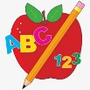 Primary 4 Homework
Week Beginning: 6th October 2025
Here is a guide to help you for this week. You can choose how to organise your tasks to suit what works for you.
Homework will be collected in on a Friday as there will not be any homework at the weekend.
Spelling |  | Reading |  | Numeracy
Please complete 2 active and 2 written spelling activities for your words.  Activities list on blog.  Stage 4  This week we are learning the ‘ee’ sound with spellings ‘ee’ ‘ea’ ‘e-e’ ‘ey’ ‘y’ ‘e’ ‘ie’ ‘eo’ ‘ei’  Rex  This week we are consolidating the ‘ie’ (tried) sound.  Forky  This week we are learning the ‘ll’ sound.  https://www.bbc.co.uk/bitesize/articles/z4v4cqt  Spelling lists are below. | Enjoy reading your book at home.  Can you spot any of your phoneme words?    Discuss the different features of non-fiction texts with someone at home.  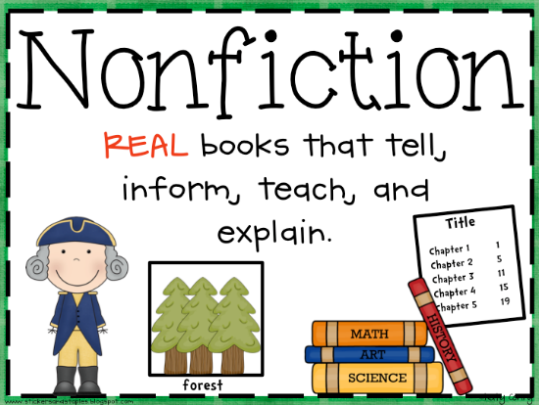 |  | Click on the Learning Intention to play the games.  LI – To double and half numbers.  LI – To practice number bonds.  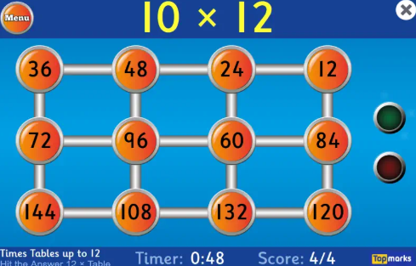  LI – To add and subtract.  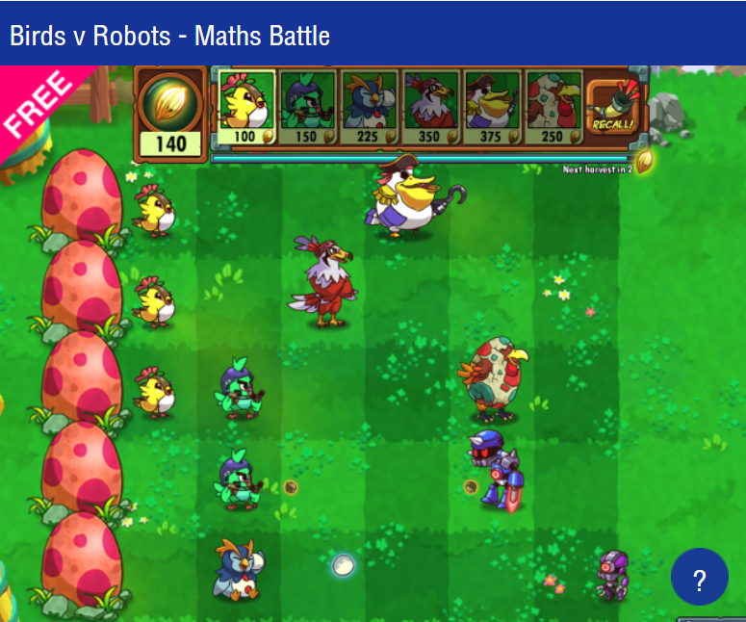

Stage 4 | Rex | Forky
agreed  street  speak  realise  here  money  key  happy  quickly  begin  field  chief  Common Words  together  buy  eye | pie  lie  die  tie  tied  cried  tried  fries  dried  lied  Common Words  together  buy  eye | sell  bell  fell  yell  will  hill  gull  spill  still  Common Word  well  tell  will  call  small

