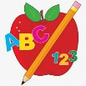 Primary 4 Homework
Week Beginning: 29th September 2025
Here is a guide to help you for this week. You can choose how to organise your tasks to suit what works for you.
Homework will be collected in on a Friday as there will not be any homework at the weekend.
Spelling |  | Reading |  | Numeracy
Please complete 2 active and 2 written spelling activities for your words.  Activities list on blog.  Stage 4  This week we are learning the ‘d’ sound with spellings ‘d’ ‘dd’ ‘-ed’ ‘de’ ‘dh’.  Rex  This week we are consolidating the ‘ea’ (bread) sound.  Forky  This week we are learning the ‘ss’ sound.  https://www.bbc.co.uk/bitesize/articles/zkbk92p  Spelling lists are below. | Enjoy reading your book at home.  Can you spot any of your phoneme words?    Are there any unknown words in your story? How could you work out the meaning of them? Use your metalinguistic skills.  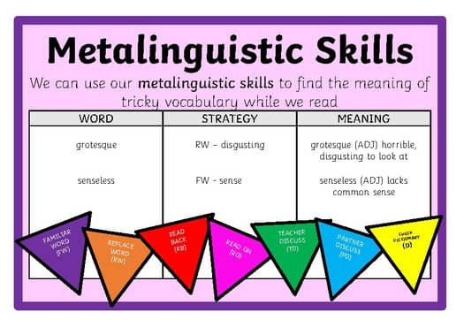 |  | Click on the Learning Intention to play the games.  LI – To round and estimate to add.    LI – To find the difference between.  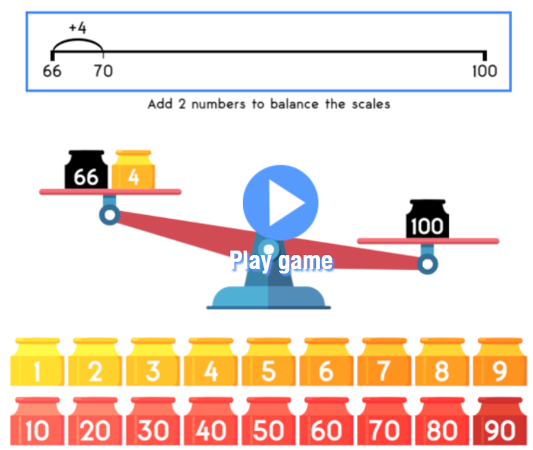

Stage 4 | Rex | Forky
decorate  tangled  dog  delicious  muddle  disapprove  adopted  unbalanced  doodles  mud  middle  donkey  Common Words  Revise Stage 3 Common Words  (List on Blog – Homework tab) | head  dead  bread  deaf  read  ready  weather  feather  health  spread  Common Words  head  pretty  another | mess  miss  moss  kiss  dress  chess  boss  fuss  class  press  Common Word  I’m

