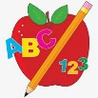 Primary 4 Homework
Week Beginning: 22nd September 2025
Here is a guide to help you for this week. You can choose how to organise your tasks to suit what works for you.
Homework will be collected in on a Friday as there will not be any homework at the weekend.
Spelling | Reading | Numeracy
Please complete 2 active and 2 written spelling activities for your words.  Activities list on blog.  Stage 4  This week we are consolidating the spelling of our Stage 3 common words.  Rex  This week we are consolidating the ‘wr’ ‘wa’ and ‘a’ sounds.  Forky  This week we are consolidating the ‘ay’ ‘ea’ and ‘y’ sounds.  Spelling lists are below. | Enjoy reading your book at home.  Can you spot any of your phoneme words?    Are there any unknown words in your story? How could you work out the meaning of them? Use your metalinguistic skills.  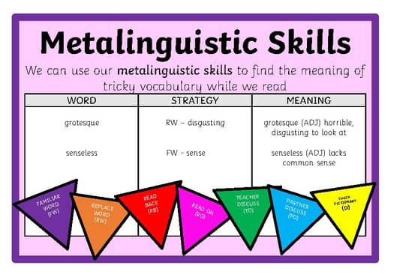 | Click on the Learning Intention to play the games.  LI – To round numbers to the nearest 10, 100.    LI – To round and estimate to add.  

Stage 4 | Rex | Forky
Common Words  Revise Stage 3 Common Words  (List on Blog – Homework tab)  Choose 10 common words that you struggle to spell (activity has been done in class) and practice spelling these words.  Mastered spelling those words?  Choose another 10 to practice. | wr, wa, a  write  wrong  wrapping  walk  wall  swallow  wander  talk  also  always | ay, ea, y  playing  clay  today  sea  meat  cheat  puppy  funny  angry  rainy

