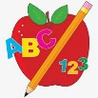 Primary 4 Homework
Week Beginning: 15th September 2025
Here is a guide to help you for this week. You can choose how to organise your tasks to suit what works for you.
Homework will be collected in on a Friday as there will not be any homework at the weekend.
Spelling | Reading | Numeracy
Please complete 2 active and 2 written spelling activities for your words.  Activities list on blog.  Stage 4  This week we are learning the /b/ sound and the spelling to represent it. ‘b’ ‘bb’ ‘bu’ ‘pb’  Rex  This week we are learning the ‘al’ sound and spelling.  Forky  This week we are learning the ‘y’ spelling with ‘ee’ and ‘ay’ sounds.  Spelling lists are below. | Enjoy reading your book at home.  Can you spot any of your phoneme words?    Retell the story to someone as home. Use the Retelling Road Map to help you.  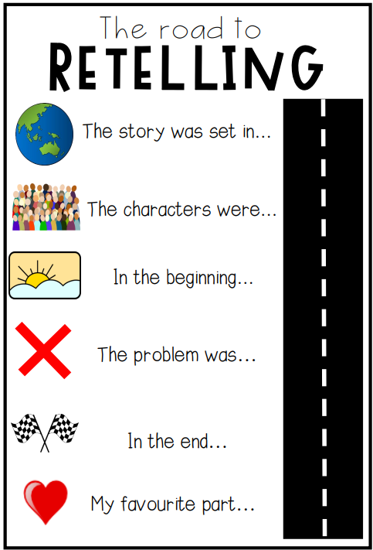 | Click on the Learning Intention to play the games.  LI – To round numbers to the nearest 10, 100.  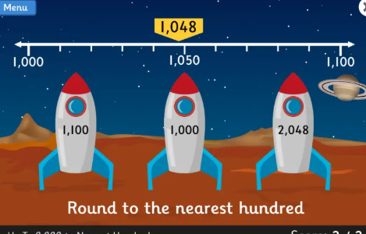  LI – To practice times tables.  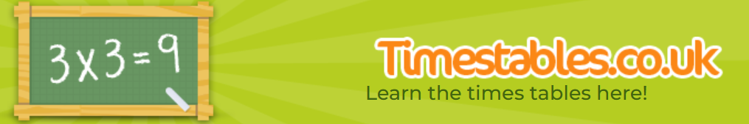

Stage 4 | Rex | Forky
busy  cupboard  buying  bubble  builder  stubble  bedroom  bedroom  rabble  babble  scribble  best  wardrobe  Common Words  Revise Stage 3 Common Words  (List on Blog – Homework tab) | all  tall  hall  talk  also  always  small  fall  Common Words  call  fall  talk  also | happy  very  funny  sunny  story  rainy  body  puppy  Common Words  funny  very  any  only

