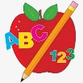 Primary 4 Homework
Week Beginning: 8th September 2025
Here is a guide to help you for this week. You can choose how to organise your tasks to suit what works for you.
Homework will be collected in on a Friday as there will not be any homework at the weekend.
Spelling | Reading | Numeracy
Please complete 2 active and 2 written spelling activities for your words.  Activities list on blog.  Stage 4  This week we are learning the ‘a’ sound and the spelling to represent it.  Rex  This week we are learning the ‘wa’ sound and spelling.  Forky  This week we are learning the ‘ea’ sound and spelling.  Spelling lists are below. | Enjoy reading your book at home.  Can you spot any of your phoneme words?    Retell the story to someone as home. Use the Retelling Road Map to help you.  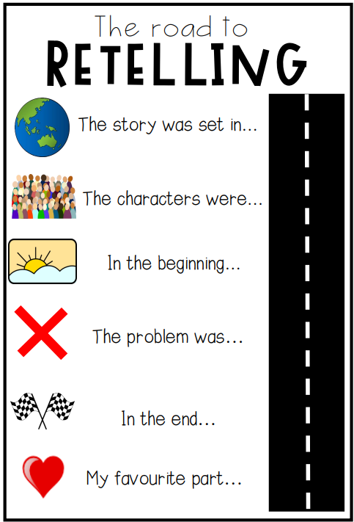 | Click on the Learning Intention to play the games.  LI – To compare and order numbers.  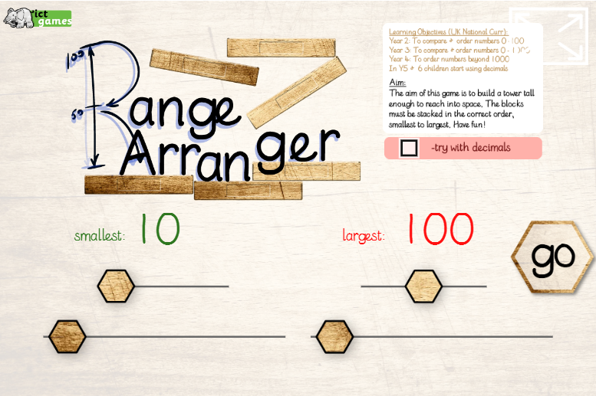  LI – To identify numbers between.  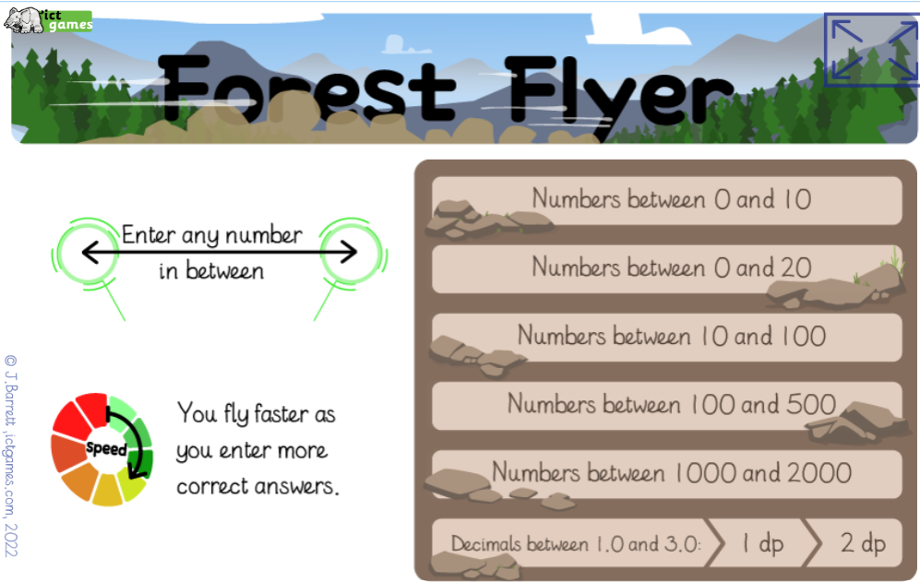

Stage 4 | Rex | Forky
basket  almond  argue  massive  alarming  attached  balmy  splashed  palm  plastic  calm  parted  Common Words  Revise Stage 3 Common Words  (List on Blog – Homework tab) | was  walk  want  was  wall  warm  swan  wasp  Common Words  walk  seven  eight | tea  sea  beans  team  leaf  clean  speak  beach  Common Words  eat  as  has

