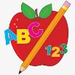 **Primary 2/3 Homework** 

**Week Beginning: 2nd December 2024**

Here is a guide to help you for this week. You can choose how to organise your tasks to suit what works for you.

Please bring book bags to school every day. They will be collected in on a Friday as there will not be any homework at the weekend.

|  |  |  |
| --- | --- | --- |
|  | **Literacy** | **Numeracy** |
|  | **Spelling**  Please complete 2 active and 2 written spelling activities for your words.  Activities list on blog.   |  | | --- | | **Woody**  This week we are learning about the ‘ch’ (c) sound.  any body carry along story  school chorus chemist Christmas  Chord headache choral | | **Buzz Lightyear, Little Aliens, Rex**  This week we are learning about the ‘ou’ sound.  round found wish men  count house sound mouse outside | | Click on the Learning Intention to play the games.   |  | | --- | | Whole Class  Create a diary for one day through the week of your daily routine. Write down what time you did the activity at. | | Whole Class  [LI – To read o’clock and half and quarter past.](https://www.sheppardsoftware.com/math/time/clock-splat-game/)    <https://www.sheppardsoftware.com/math/time/clock-splat-game/> | |
|  | **Reading**  Enjoy reading your book at home.  Can you spot any of your phoneme words? |

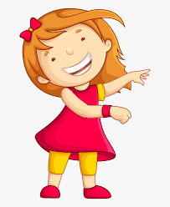Remember to have lots of fun! [](https://www.google.co.uk/url?sa=i&url=https://www.clipart.email/clipart/child-happy-clipart-147083.html&psig=AOvVaw15KElXbPSE2k0Wq8C2DJHG&ust=1589482978254000&source=images&cd=vfe&ved=0CAIQjRxqFwoTCKjumtTDsekCFQAAAAAdAAAAABAL)