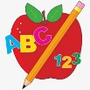 **Primary 2/3 Homework** 

**Week Beginning: 18th November 2024**

Here is a guide to help you for this week. You can choose how to organise your tasks to suit what works for you.

Please bring book bags to school every day. They will be collected in on a Friday as there will not be any homework at the weekend.

|  |  |  |
| --- | --- | --- |
|  | **Literacy** | **Numeracy** |
|  | **Spelling**  Please complete 2 active and 2 written spelling activities for your words.  Activities list on blog.   |  | | --- | | **Woody**  This week we are learning about the ‘g’ (j) sound.  about around house hour side  danger magic gentle energy germs  gym stranger | | **Buzz Lightyear, Little Aliens, Rex**  This week we are learning about the ‘ew’ sound.  what many soon book  drew flew chew grew threw  blew | | Click on the Learning Intention to play the games.   |  | | --- | | Whole Class  [LI – To round to the next ten.](https://www.topmarks.co.uk/maths-games/rocket-rounding)   * 1. Up to 99 to the Nearest Ten   2. Up to 999 to the Nearest Ten     <https://www.topmarks.co.uk/maths-games/rocket-rounding> | | Whole Class  [LI – To read o’clock and half past.](https://mathsframe.co.uk/en/resources/resource/116/telling-the-time)  Choose level 1 or 2.  Choose 12 hour clock.    <https://mathsframe.co.uk/en/resources/resource/116/telling-the-time> | |
|  | **Reading**  Enjoy reading your book at home.  Can you spot any of your phoneme words? |

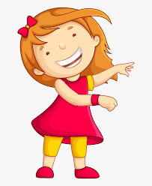Remember to have lots of fun! [](https://www.google.co.uk/url?sa=i&url=https://www.clipart.email/clipart/child-happy-clipart-147083.html&psig=AOvVaw15KElXbPSE2k0Wq8C2DJHG&ust=1589482978254000&source=images&cd=vfe&ved=0CAIQjRxqFwoTCKjumtTDsekCFQAAAAAdAAAAABAL)