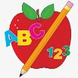 **Primary 2/3 Homework** 

**Week Beginning: 11th November 2024**

Here is a guide to help you for this week. You can choose how to organise your tasks to suit what works for you.

Please bring book bags to school every day. They will be collected in on a Friday as there will not be any homework at the weekend.

|  |  |  |
| --- | --- | --- |
|  | **Literacy** | **Numeracy** |
|  | **Spelling**  Please complete 2 active and 2 written spelling activities for your words.  Activities list on blog.   |  | | --- | | **Woody**  This week we are learning about the ‘ve’ sound.  own small something live give  have dove leave believe retrieve  starve relieve | | **Buzz Lightyear, Little Aliens, Rex**  This week we are learning about the ‘au’ sound.  because week keep when  sauce applaud pause Paul  Laura | | Click on the Learning Intention to play the games.   |  | | --- | | Whole Class  [LI – To round to the next ten.](https://www.topmarks.co.uk/maths-games/rocket-rounding)   * 1. Up to 99 to the Nearest Ten   2. Up to 999 to the Nearest Ten     <https://www.topmarks.co.uk/maths-games/rocket-rounding> | | Whole Class  [LI – To partition numbers.](https://www.topmarks.co.uk/maths-games/daily10)  Click Level 2/ Level 3 ‘Partitioning’.    <https://www.topmarks.co.uk/maths-games/daily10> | |
|  | **Reading**  Enjoy reading your book at home.  Can you spot any of your phoneme words? |

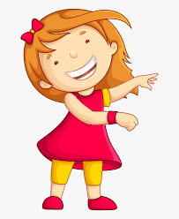Remember to have lots of fun! [](https://www.google.co.uk/url?sa=i&url=https://www.clipart.email/clipart/child-happy-clipart-147083.html&psig=AOvVaw15KElXbPSE2k0Wq8C2DJHG&ust=1589482978254000&source=images&cd=vfe&ved=0CAIQjRxqFwoTCKjumtTDsekCFQAAAAAdAAAAABAL)