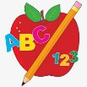 **Primary 2/3 Homework** 

**Week Beginning: 16th September 2024**

Here is a guide to help you for this week. You can choose how to organise your tasks to suit what works for you.

Please bring book bags to school every day. They will be collected in on Thursday this week as it is a long weekend.

|  |  |  |
| --- | --- | --- |
|  | **Literacy** | **Numeracy** |
|  | **Spelling**  Please complete 2 active and 2 written spelling activities for your words.  Activities list on blog.   |  | | --- | | **Woody**  gave family how might  write wrist wrote wrong wrinkle wreck wrap written | | **Buzz Lightyear, Little Aliens, Rex**  each ask year  eat speak clean steal team stream  wheat | | **Numbers to 100**  Your child will have their 100 square in their book bags. Ask your child to point to different numbers. Ask your child to find the number before, after and in-between.    *This can be kept in your child’s book bag to help them with any numbers to 100 activities. |
|  | **Reading**  Enjoy reading your book at home.  Can you spot any of your phoneme words? |

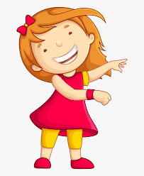Remember to have lots of fun! [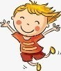](https://www.google.co.uk/url?sa=i&url=https://www.clipart.email/clipart/child-happy-clipart-147083.html&psig=AOvVaw15KElXbPSE2k0Wq8C2DJHG&ust=1589482978254000&source=images&cd=vfe&ved=0CAIQjRxqFwoTCKjumtTDsekCFQAAAAAdAAAAABAL)