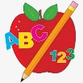 Primary 3 Homework
Week Beginning: 3rd June 2024
Here is a guide to help you for this week. You can choose how to organise your tasks to suit what works for you.
Please bring book bags to school every day. They will be collected in on a Friday as there will not be any homework at the weekend.
 | Literacy | Numeracy
 | Spelling  Please complete 2 active and 2 written spelling activities for your words.  Activities list on blog.  Woody, Forky and Buzz Lightyear  try real eye low animal such chef machine chalet brochure parachute chute  Little Aliens  five time life line side white smile hide shine  Rex  each ask year eat speak clean steal  team stream wheat | Click on the Learning Intention to play the games.  Length  LI – To measure in cm.  https://www.topmarks.co.uk/maths-games/measuring-in-cm
 | Reading  LI – We are learning to read fluently.  Stitch  The Valley of Diamonds  Super Slinky  Animals to the Rescue  Angel  King Julien and the Rain Dance  Arctic  City Shapes  Jet  Shadows in the Sun | Active Length  Long Jump  Mark your starting point, take a jump, and then measure the distance you’ve covered using a measuring tape, ruler or even just your feet.  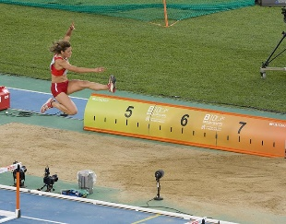
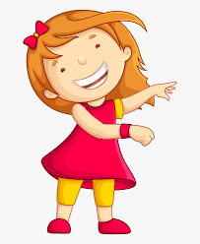Remember to have lots of fun!

