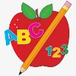 Primary 3 Homework
Week Beginning: 20th May 2024
Here is a guide to help you for this week. You can choose how to organise your tasks to suit what works for you.
Please bring book bags to school every day. They will be collected in on a Friday as there will not be any homework at the weekend.
 | Literacy | Numeracy
 | Spelling  Please complete 2 active and 2 written spelling activities for your words.  Activities list on blog.  Woody, Forky and Buzz Lightyear  month together work Sunday Saturday done brother none son nothing worry work  Little Aliens  who after hand right high thigh bright might light  Rex  fair stair hair air chair lair rain pain grain brain | Click on the Learning Intention to play the games.  Money  LI – To give change.  https://ictgames.com/mobilePage/payForIt/index.html
Reading
LI – We are learning to use expression.

Stitch
Mona the Moaner
Super Slinky
Blood Buns and Scarecrows
Angel
Tricking Our Eyes
Arctic
Slow and Sticky
Jet
Eco Apes Grow Food

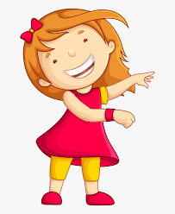Remember to have lots of fun!

