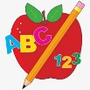 Primary 3 Homework
Week Beginning: 13th May 2024
Here is a guide to help you for this week. You can choose how to organise your tasks to suit what works for you.
Please bring book bags to school every day. They will be collected in on a Friday as there will not be any homework at the weekend.
 | Literacy | Numeracy
 | Spelling  Please complete 2 active and 2 written spelling activities for your words.  Activities list on blog.  Woody, Forky and Buzz Lightyear  does changes show think same fudge bridge hedge ledge judge badger fridge  Little Aliens  count mouth south house mouse cloud mountain bounce out round  Rex  quit quiet quick quack quiz quote squad queen squid square | Click on the Learning Intention to play the games.  Money  LI – To calculate the amount of change.  https://natwest.mymoneysense.com/students/students-5-8/the-change-game/
 | Reading  LI – We are learning to use expression.  Stitch  The Not-So Merry-Go-Round  Super Slinky  Going into Space  Angel  Dino-Splashing  Arctic  Martial Arts  Jet  Get the Map | Active Money  Investigate equivalent money values.  Find different ways to make:  - 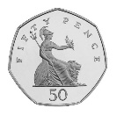 20p + 20p + 10p  - 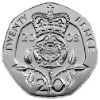  - 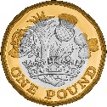  - 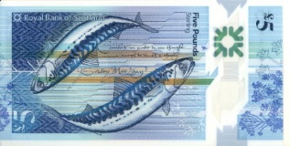
Remember to have lots of fun!

