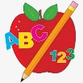 Primary 3 Homework
Week Beginning: 29th April 2024
Here is a guide to help you for this week. You can choose how to organise your tasks to suit what works for you.
Please bring book bags to school every day. They will be collected in on a Friday as there will not be any homework at the weekend.
 | Literacy | Numeracy
 | Spelling  Please complete 2 active and 2 written spelling activities for your words.  Activities list on blog.  Woody, Forky and Buzz Lightyear  gym pyramid rhythm pull push bull  sign gnome gnash design  Little Aliens  brow now owl growl brown clown down prowl frown crowd  Rex  this thank that think thing path tooth both three sloth | Click on the Learning Intention to play the games.  LI – To give an exact amount.  https://www.topmarks.co.uk/money/toy-shop-money
 | Reading  LI – We are learning to use expression.  Stitch  The Great Getaway  Super Slinky  Fossils  Angel  Colourful Creatures  Arctic  Brave Little Beasts  Jet  Chit Chat | Active Money  Can you identify different coins at home? Pick 2 or 3 different coins and add them together.  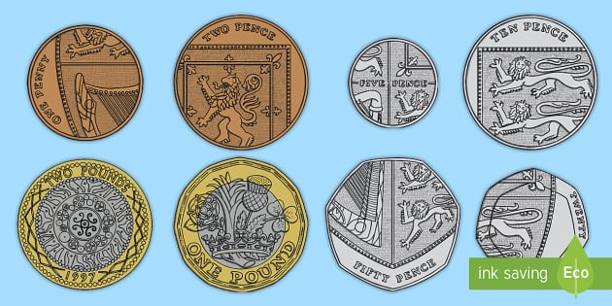
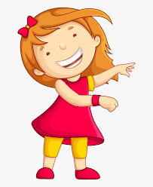Remember to have lots of fun!

