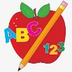 Primary 3 Homework
Week Beginning: 15th April 2024
Here is a guide to help you for this week. You can choose how to organise your tasks to suit what works for you.
Please bring book bags to school every day. They will be collected in on a Friday as there will not be any homework at the weekend.
 | Literacy | Numeracy
 | Spelling  Please complete 2 active and 2 written spelling activities for your words.  Activities list on blog.  Woody, Forky and Buzz Lightyear  put different light sentence stop pull push cushion full bush awful bull  Little Aliens  because week keep when  sauce applaud pause Paul Laura  Rex  out now new  what wheel whisk when whiskers why | Click on the link to play the games.  Mental Maths  Choose your own times tables to practice.  https://www.topmarks.co.uk/maths-games/hit-the-button  Fractions  LI – To match fractions.  https://phet.colorado.edu/sims/html/fraction-matcher/latest/fraction-matcher_en.html
 | Reading  LI – We are learning to use expression.  Stitch  Caring for Exotic Animals  Super Slinky  Flint the Inventor  Angel  Dino-sitting  Arctic  Trapped in a Tower  Jet  Stop that Pram! | Active Fractions  Go outdoor and find sticks of different sizes.  Can you create your own fraction wall?  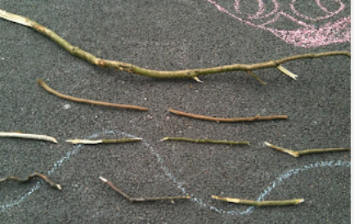
Remember to have lots of fun!

