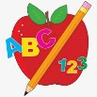 Primary 3 Homework
Week Beginning: 4th March 2024
Here is a guide to help you for this week. You can choose how to organise your tasks to suit what works for you.
Please bring book bags to school every day. They will be collected in on a Friday as there will not be any homework at the weekend.
 | Literacy | Numeracy
 | Spelling  Please complete 2 active and 2 written spelling activities for your words.  Activities list on blog.  Woody, Forky and Buzz Lightyear  walk water picture once until thought brought fought bought  Little Aliens  jaw draw hawk crawl saw  low throw follow yellow show  Rex  tray play stay day away  church much chin chip lunch | Click on the Learning Intention to play the games.  LI – To divide.  Select Level 2 or 3 -> Division -> Select a division table to practice -> Select your time.  https://www.topmarks.co.uk/maths-games/daily10
 | Reading  LI – We are learning to use expression and fluency.  Stitch  Superpet!  Super Slinky  Best Birthday Ever!  Angel  Chase in New York  Artic  The Missing Masks  Jet  Bob is Glum | Active Division  Using things at home and your division strategies, practice dividing by 2, 5 and 10.  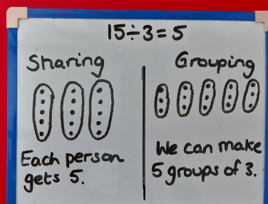  Go down / turn page for practice sheet.

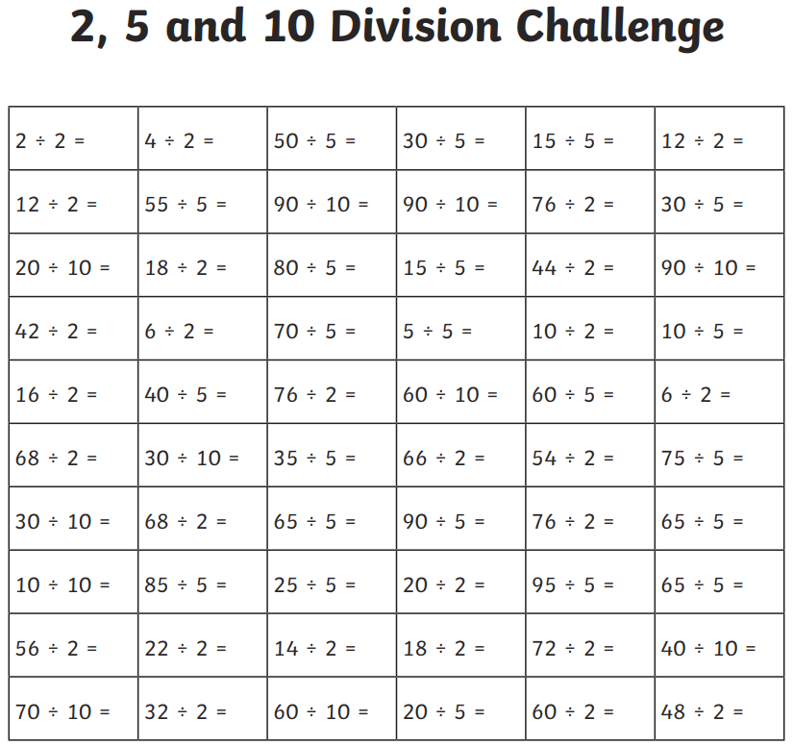
Remember to have lots of fun!

