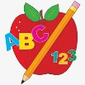 Primary 3 Homework
Week Beginning: 26th February 2024
Here is a guide to help you for this week. You can choose how to organise your tasks to suit what works for you.
Please bring book bags to school every day. They will be collected in on a Friday as there will not be any homework at the weekend.
 | Literacy | Numeracy
 | Spelling  Please complete 2 active and 2 written spelling activities for your words.  Activities list on blog.  Woody, Forky and Buzz Lightyear  write answer began heat page hoe goes heroes doe potatoes tomatoes foe  Little Aliens  sauce pause applaud drew chew blew boat road coat  Rex  said could her before bucket brain stair boy royal road quick queen | Click on the Learning Intention to play the games.  LI – To group amounts.  https://kids.classroomsecrets.co.uk/resource/year-2-make-equal-groups-grouping-game/  Division  Select Division – Year 1, 2 or 3  https://mathsframe.co.uk/en/resources/resource/582/Division-Mini-Maths-Golf
 | Reading  LI – We are learning to use expression.  Stitch  Going Into Space  Super Slinky  The Great Escape  Angel  Exploring London  Arctic  What We Do All Day  Jet  The Gift | Active Division  Use things at home to group into equal amounts.  Write the division calculation for it.  8 ÷ 2 = 4  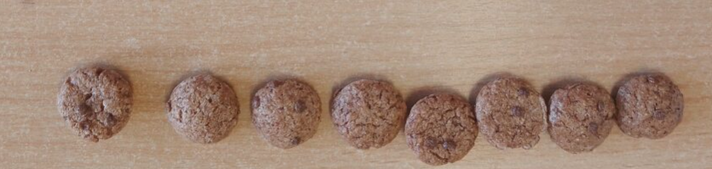  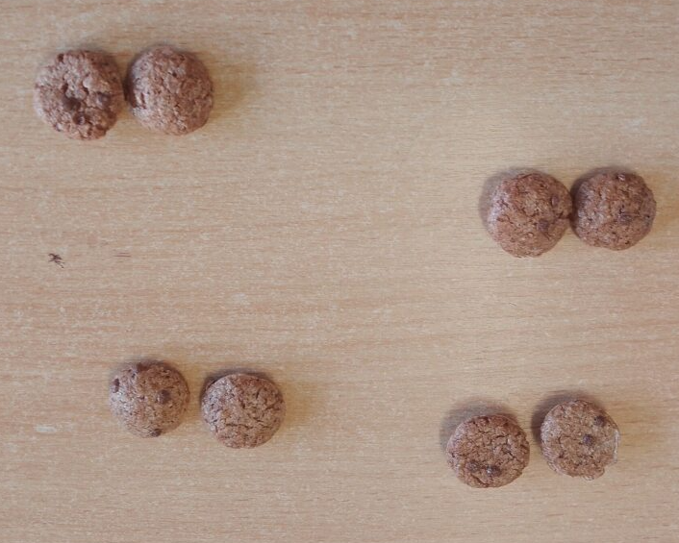
Remember to have lots of fun!

