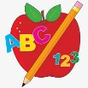 Primary 3 Homework
Week Beginning: 22nd January 2024
Here is a guide to help you for this week. You can choose how to organise your tasks to suit what works for you.
Please bring book bags to school every day. They will be collected in on a Friday as there will not be any homework at the weekend.
 | Literacy | Numeracy
 | Spelling  Please complete 2 active and 2 written spelling activities for your words.  Activities list on blog.  Woody, Buzz Lightyear and Little Aliens  read call even fly close they obey prey survey convey grey  Rex  owl brown growl crown allow  count house outside sound mouse | Click on the Learning Intention to play the games.  LI – To multiply using arrays.  Choose your own array quiz.  https://wordwall.net/en-us/community/arrays  Multiplication Practice  Select Year 2 or 2, 5 or 10 times tables.  ** Challenge – Year 3  https://mathsframe.co.uk/en/resources/resource/383/Marlons-Magical-Maths-Mission-Multiplication
 | Reading  LI – We are learning to use expression.  We are learning to answer prove it questions.  Use the question to answer in a complete sentence.  Stitch  Weird Weather  Why would Flint be worried that the food was getting bigger and bigger?  Super Slinky  Pirates Life at Sea  Why would pirates have to have a set of rules?  Angel  Materials Around Us  Why would food be ground up into small bits?  Arctic  The Cake Sale Goo  Why did the women cover the baby’s eyes on page 15?  Jet  Lost  Why did Sam think Mum got lost? | Active Multiplication  Can you find arrays used in real life?  For example –  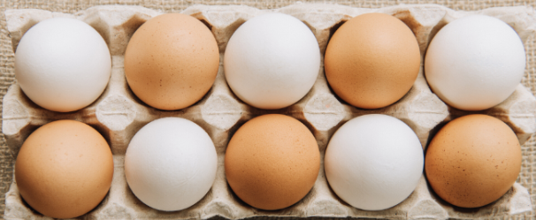  2 rows of 5  5 + 5  2 x 5
 | Class Assembly
We will be practicing our class assembly this month to get ready for our performance in February.
Use your script to practice your part at home and in school.
Scots Poem Recital
We are learning to recite a poem.
In P3 we will be learning and reciting ‘The Sair Finger’ by Walter Wingate.
Use your own copy to practice at home, and you can watch this performance to help you.

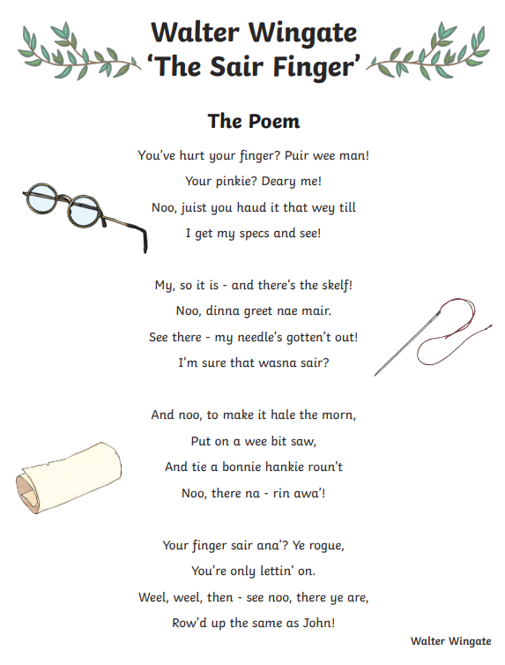
‘The Sair Finger’ performed by Ciara Brady.
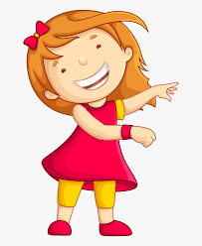Remember to have lots of fun! 