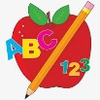 Primary 3 Homework
Week Beginning: 22nd January 2024
Here is a guide to help you for this week. You can choose how to organise your tasks to suit what works for you.
Please bring book bags to school every day. They will be collected in on a Friday as there will not be any homework at the weekend.
 | Literacy | Numeracy
 | Spelling  Please complete 2 active and 2 written spelling activities for your words.  Activities list on blog.  Woody, Buzz Lightyear and Little Aliens  should would open song hard mousse wound group routine youth acoustic could  Rex  round found wish men count house outside sound mouse | Click on the Learning Intention to play the games.  LI – To multiply using repeated addition.  Choose your own repeated addition quiz.  https://wordwall.net/en-us/community/repeated-addition  LI – To multiply using skip counting.  Choose your own skip counting quiz.  https://wordwall.net/en-us/community/skip-counting  Multiplication Practice  Select Year 2 or 2, 5 or 10 times tables.  https://mathsframe.co.uk/en/resources/resource/383/Marlons-Magical-Maths-Mission-Multiplication
 | Reading  LI – We are learning to use expression.  We are learning to answer find it questions.  Use the question to answer in a complete sentence.  Stitch  FLINT The Inventor  Why did Flint look sadly out to sea?  Super Slinky  The Wrong Jumper  Why did Pete think Mrs Muddyboot wanted a jumping animal?  Angel  Swampy Mess  Why was Horribilly sleepy?  Arctic  A Little Look at Big Reptiles  Why does a crocodile have sharp teeth?  Jet  Stunt Rat  Why is Ken lifting twigs? | Active Multiplication  Create your own skip counting patterns at home with the x2, x4, x5, x10.  Here are some ideas for you:  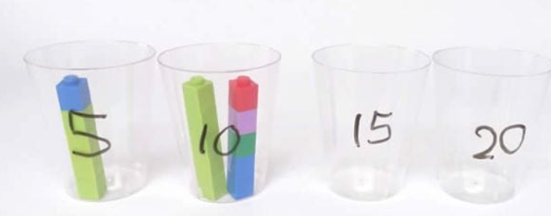  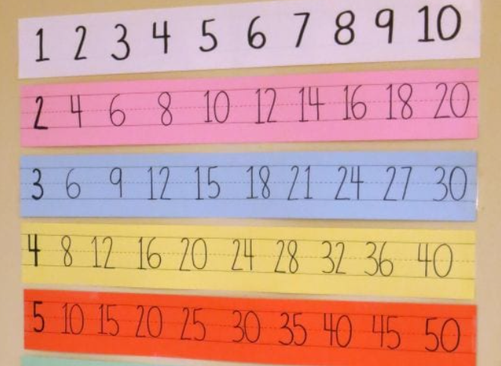
 | Class Assembly
We will be practicing our class assembly this month to get ready for our performance in February.
Use your script to practice your part at home and in school.
Scots Poem Recital
We are learning to recite a poem.
In P3 we will be learning and reciting ‘The Sair Finger’ by Walter Wingate.
Use your own copy to practice at home, and you can watch this performance to help you.

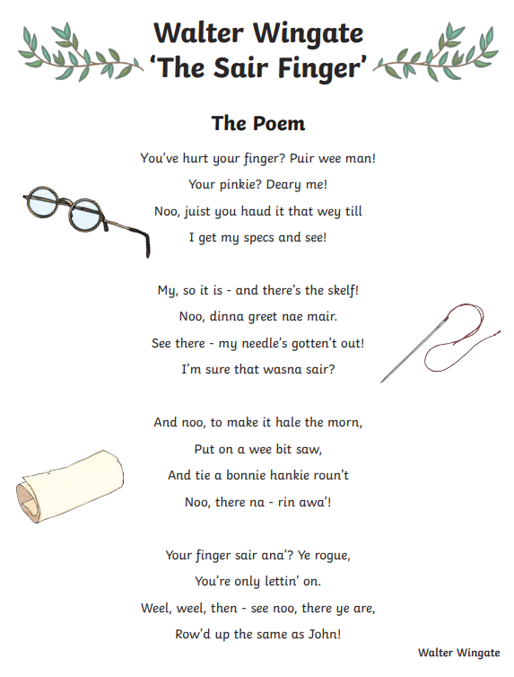
‘The Sair Finger’ performed by Ciara Brady.
Remember to have lots of fun!

