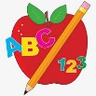 Primary 3 Homework
Week Beginning: 15th January 2024
Here is a guide to help you for this week. You can choose how to organise your tasks to suit what works for you.
Please bring book bags to school every day. They will be collected in on a Friday as there will not be any homework at the weekend.
 | Literacy | Numeracy
 | Spelling  Please complete 2 active and 2 written spelling activities for your words.  Activities list on blog.  Woody, Buzz Lightyear and Little Aliens  white why also turn great break steak thread spread dread health tread  Rex  how where now too owl brown growl crown allow | Click on the Learning Intention to play the games.  Addition and Subtraction Practice  https://www.topmarks.co.uk/maths-games/mental-maths-train  Multiplication  Select Year 2 or 2, 5 or 10 times tables.  https://mathsframe.co.uk/en/resources/resource/504/Super-Maths-Bowling-Multiplication
 | Reading  LI – We are learning to use expression.  We are learning to answer find it questions.  Use the question to answer in a complete sentence.  Woody The Truth About Fish and Chips Where did the first fried-fish recipe come from? Woody  Buzz Lightyear Robber Run-Around What did Sam the snake do to stop the robber? Buzz Lightyear  Little Aliens Plant Traps What happens to insects that land on sticky leaves? Little Aliens  Rex Eco Apes Save Water At the beginning, what did Bob use to save water? Rex | Active Multiplication  LI – We are learning to create and use equal groups.  Use items at home to create equal groups to solve these multiplication calculations.  2 x 3 | 4 x 6 | 10 x 5 | 7 x 9 | 8 x 6 | 6 x 7  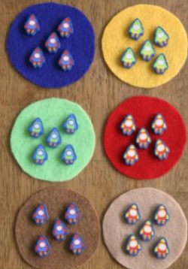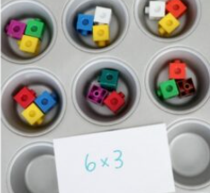
 | Class Assembly
We will be practicing our class assembly this month to get ready for our performance in February.
Use your script to practice your part at home and in school.

Scots Poem Recital
We are learning to recite a poem.
In P3 we will be learning and reciting ‘The Sair Finger’ by Walter Wingate.
Use your own copy to practice at home, and you can watch this performance to help you.

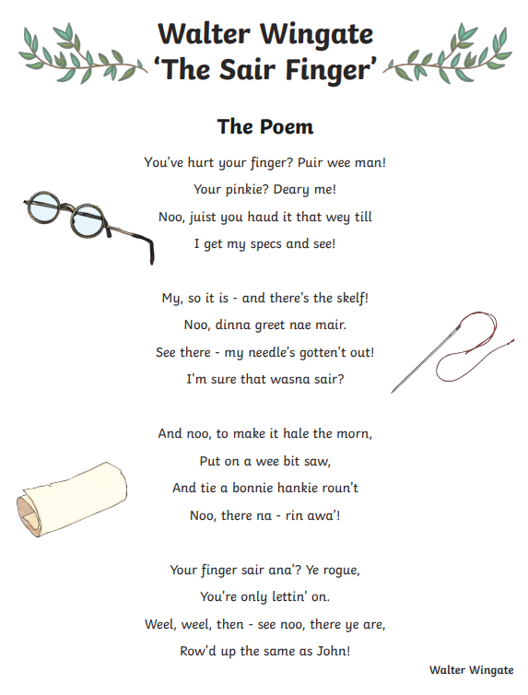
‘The Sair Finger’ performed by Ciara Brady.
Remember to have lots of fun!

