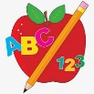 Primary 3 Homework
Week Beginning: 11th December 2023
Here is a guide to help you for this week. You can choose how to organise your tasks to suit what works for you.
Please bring book bags to school every day. They will be collected in on a Friday as there will not be any homework at the weekend.
 | Literacy | Numeracy
 | Spelling  Please complete 2 active and 2 written spelling activities for your words.  Activities list on blog.  Woody, Buzz Lightyear and Little Aliens  any body carry along story back  bird add between world city icy face place more  Rex  sauce pause Paul Laura because  drew flew chew grew threw | Click on the Learning Intention to play the games.  Addition and Subtraction Practice  Select a game and choose + or -. Select your level or press Level 1/2/3.  https://mathsframe.co.uk/en/resources/resource/563/Snowball-Smash  https://www.topmarks.co.uk/maths-games/mental-maths-train  https://mathsframe.co.uk/en/resources/resource/594/Angry-Andy-Must-Have-Candy
Reading
LI – We are learning to use expression.
We are learning to answer find it questions.
Use the question to answer in a complete sentence.
Woody
Best Birthday Ever!
Who saved the ball from hitting Asha?
Buzz Lightyear
Swampy Mess
Why were the children bored on page 10?
Little Aliens
Zeke and the Big Sandcastle
What happened when Blip tried to add shells to the sandcastle?
Rex
Be a Pirate
What does the Pirate Captain wear?

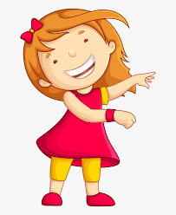Remember to have lots of fun!

