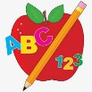 Primary 3 Homework
Week Beginning: 4th December 2023
Here is a guide to help you for this week. You can choose how to organise your tasks to suit what works for you.
Please bring book bags to school every day. They will be collected in on a Friday as there will not be any homework at the weekend.
 | Literacy | Numeracy
 | Spelling  Please complete 2 active and 2 written spelling activities for your words.  Activities list on blog.  Woody, Buzz Lightyear and Little Aliens  cheese noise please because  school chorus chemist Christmas  circle circus cinema December  Rex  what many soon book drew flew chew grew threw blew | Click on the Learning Intention to play the games.  LI – To create fact families.  https://www.topmarks.co.uk/number-facts/number-fact-families  Subtraction Practice  Subtraction -> Select your level  https://www.topmarks.co.uk/maths-games/mental-maths-train  Subtraction Practice  Subtraction -> Select your levels or press Level 2/3.  https://mathsframe.co.uk/en/resources/resource/563/Snowball-Smash  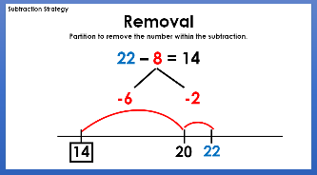  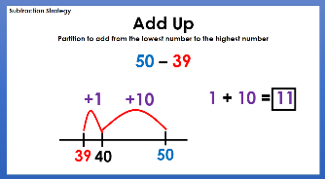  Strategies we have been learning -
Reading
LI – We are learning to use expression.
We are learning to answer find it questions. Use the question to answer in a complete sentence.

Woody
Chocolate!
What is chocolate made from?
Buzz Lightyear
Wallace and Gromit and the Autochef
Where did the eggs land?
Little Aliens
Football
What is the defenders job?
Rex
Beep Beep, Timmy!
What is Owl carrying?

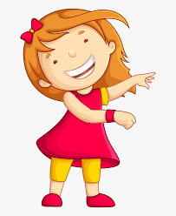Remember to have lots of fun! 