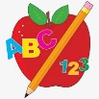 Primary 3 Homework
Week Beginning: 27th November 2023
Here is a guide to help you for this week. You can choose how to organise your tasks to suit what works for you.
Please bring book bags to school every day. They will be collected in on a Friday as there will not be any homework at the weekend.
 | Literacy | Numeracy
 | Spelling  Please complete 2 active and 2 written spelling activities for your words.  Activities list on blog.  Woody, Buzz Lightyear and Little Aliens  city icy face place more  recite central circle circus cinema celebrate December  Rex  because week keep when  sauce applaud pause Paul Laura | Click on the Learning Intention to play the games.  LI – To half numbers.  https://www.topmarks.co.uk/maths-games/hit-the-button  LI – To create fact families.  https://www.topmarks.co.uk/number-facts/number-fact-families  Subtraction Practice  Subtraction -> Select your levels or press Level 2/3.  https://mathsframe.co.uk/en/resources/resource/563/Snowball-Smash  Strategies we have been learning –  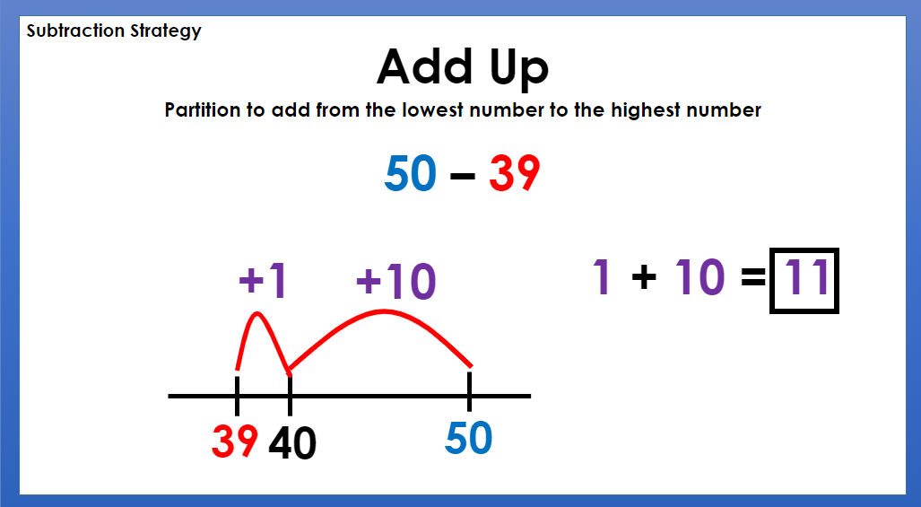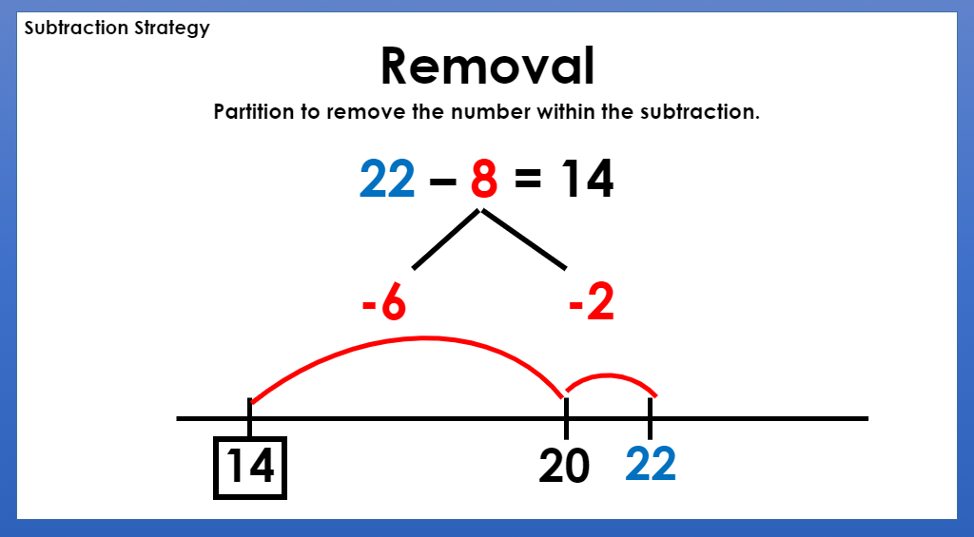
Reading
LI – We are learning to use expression.
We are learning to be answer find it questions. Use the question to answer in a complete sentence.
Woody
I Want a Unicorn!
Why did Sally sell her unicorn?
Buzz Lightyear
Epic Adventures
What was the name of the ship that Columbus travelled on?
Little Aliens
Let’s Eat lunch
What does the salad in it?
Rex
Eco Apes Use Rubbish
What do they make with the tin and cup?

Remember to have lots of fun!

