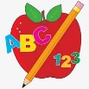 Primary 3 Homework
Week Beginning: 20th November 2023
Here is a guide to help you for this week. You can choose how to organise your tasks to suit what works for you.
 | Literacy | Numeracy
 | Spelling  Please complete 2 active and 2 written spelling activities for your words.  Woody, Buzz Lightyear and Little Aliens  back bird add between world cheese noise ease pause tease  please because  Rex  glue true clue Sue  jaw draw saw crawl  boil spoil coin join | Click on the Learning Intention to play the games.  Adding Practice  Addition -> Select your levels or press Level 2/3.  https://mathsframe.co.uk/en/resources/resource/573/Birds-v-Robots-Maths-Battle  LI – To half numbers.  https://www.topmarks.co.uk/maths-games/hit-the-button  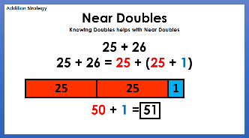  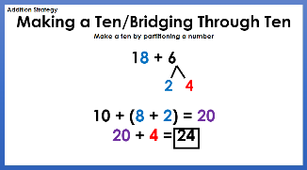  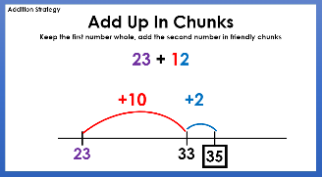  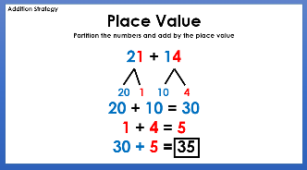  Strategies we have been learning –
Reading
LI – We are learning to use expression.
We are learning to tell a text.
Retell your book to someone at home, using the retelling strategy.
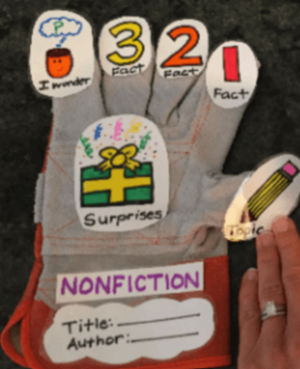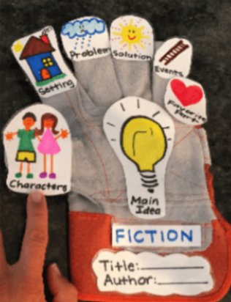
Woody
Thunderbirds Are Go: Fireflash
Buzz Lightyear
Gloopy Food
Little Aliens
Oceans
Rex
Timmy Wants To Win

Please bring book bags to school every day. They will be collected in on a Friday as there will not be any homework at the weekend.
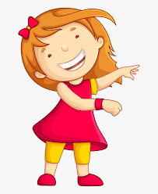Remember to have lots of fun!

