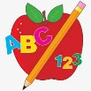 Primary 3 Homework
Week Beginning: 13th November 2023
Here is a guide to help you for this week. You can choose how to organise your tasks to suit what works for you.
Please bring book bags to school every day. They will be collected in on a Friday as there will not be any homework at the weekend.
 | Literacy | Numeracy
 | Spelling  Please complete 2 active and 2 written spelling activities for your words.  Activities list on blog.  Woody, Buzz Lightyear and Little Aliens  any body carry along story school chorus chemist Christmas chord headache choral  Rex  their some them last boil  spoil coin moist toilet join | Click on the Learning Intention to play the games.  Adding Practice  Select your level.  Remember to have a growth mindset and challenge yourself.  https://www.sheppardsoftware.com/math/addition/fruit-splat-game/  Strategies we have been learning –  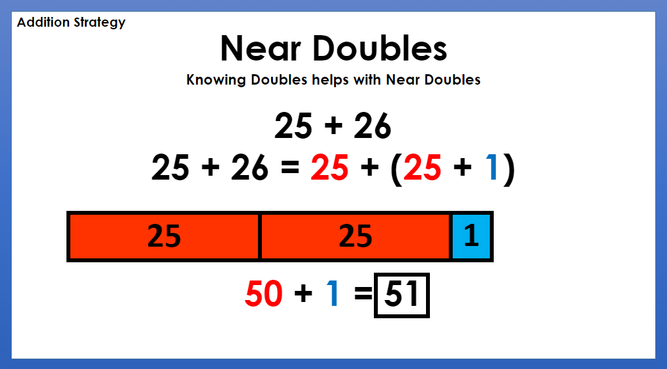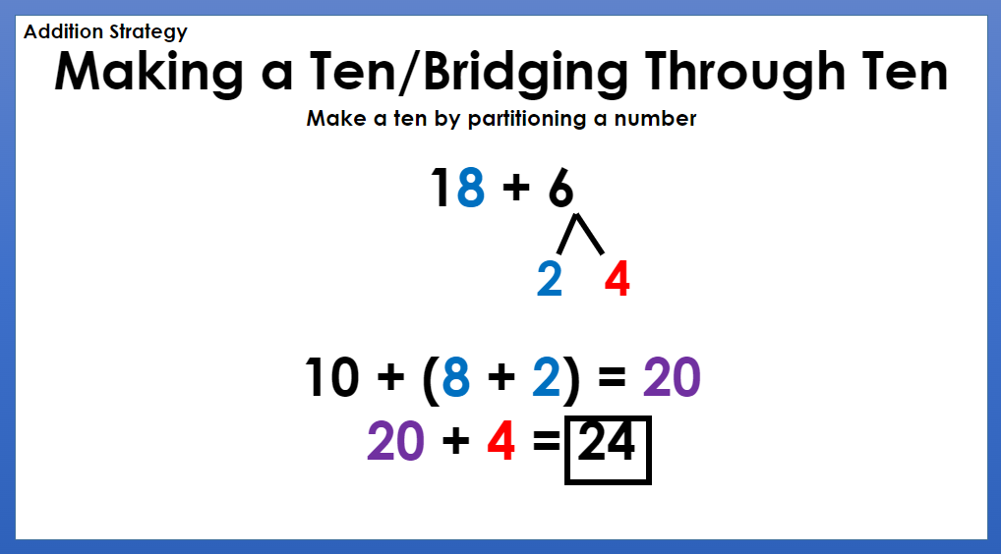  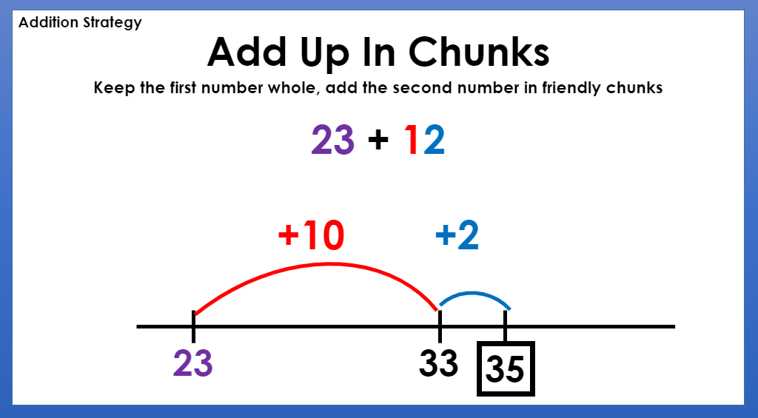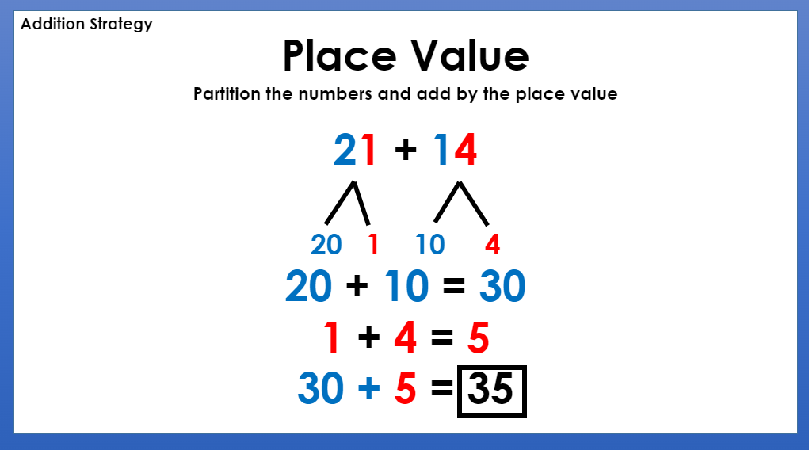
Reading
LI – We are learning to use expression.
We are learning to tell a text.
Retell your book to someone at home, using the retelling strategy.
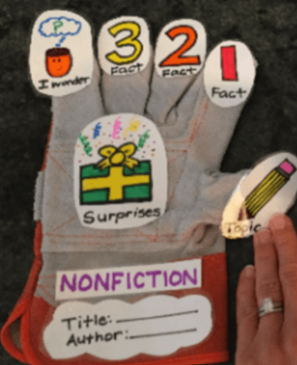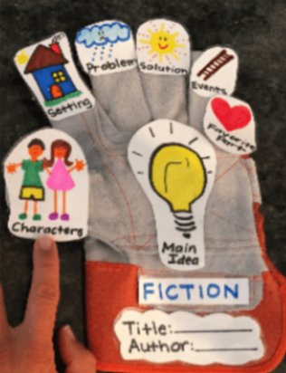
Woody
Marian to the Rescue
Buzz Lightyear
Soccomatic
Little Aliens
Ballet
Rex
We Can Do It!

 | Polar Lands Topic Challenge – Due Friday 17th November
I can create a model or life size igloo using a variety of materials

We have been learning about the Arctic and the people and animals who live there. For your homework challenge, create your own igloo. You can draw, paint or use a range of different materials.
Here are some examples –
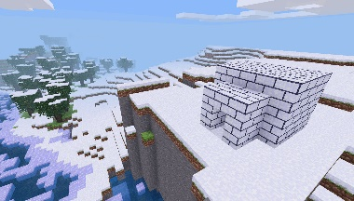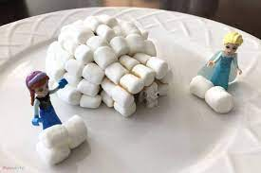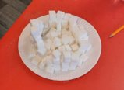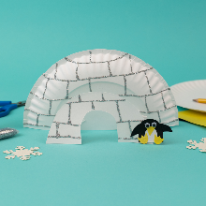
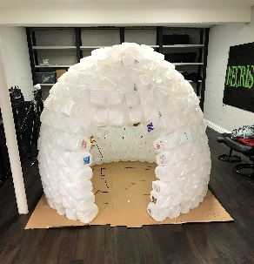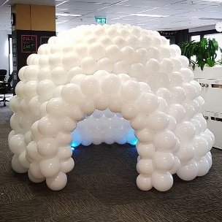
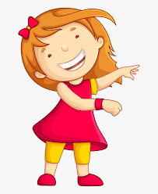Remember to have lots of fun!

