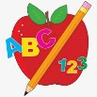 Primary 3 Homework
Week Beginning: 6th November 2023
Here is a guide to help you for this week. You can choose how to organise your tasks to suit what works for you.
Please bring book bags to school every day. They will be collected in on a Friday as there will not be any homework at the weekend.
 | Literacy | Numeracy
 | Spelling  Please complete 2 active and 2 written spelling activities for your words.  Activities list on blog.  Woody, Buzz Lightyear and Little Aliens  cried fried denied dried  give have leave starve  magic germs gym danger  Rex  very took fast there jaw  draw hawk crawl awful saw | Click on the Learning Intention to play the games.  LI – To bridge over 10s.  https://ictgames.com/mobilePage/tugofwar/index.html  Adding Practice  Choose + and select your level.  Remember to have a growth mindset and challenge yourself.  https://www.topmarks.co.uk/maths-games/mental-maths-train  Strategies we have been learning –  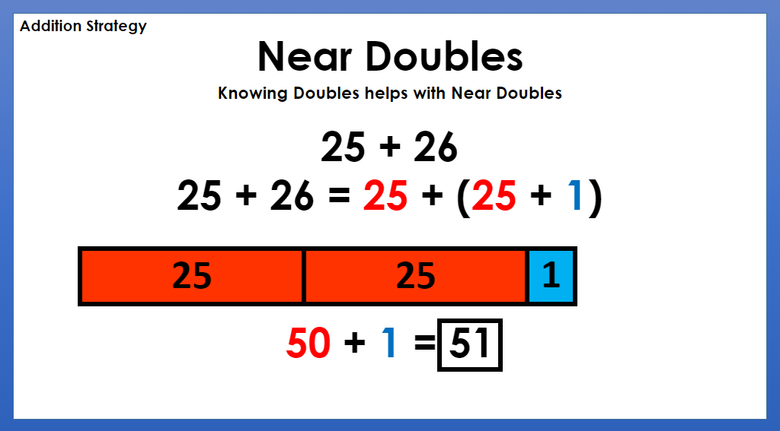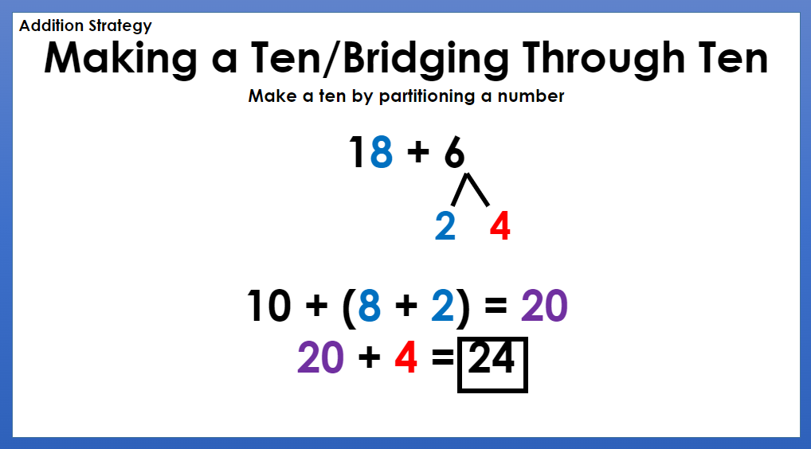
Reading
LI – We are learning to use expression.
We are learning to tell a text.
Retell your book to someone at home, using the retelling strategy.
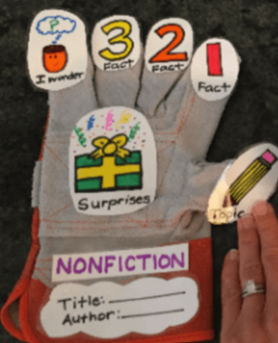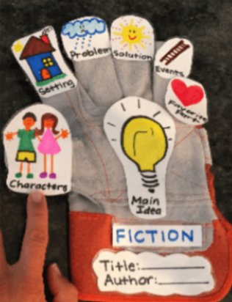
Woody
All About Mummies
Buzz Lightyear
Amazing Trees
Little Aliens
Nowhere To Go!
Rex
When Can I Get On?

 | Polar Lands Topic Challenge – Due Friday 17th November
I can create a model or life size igloo using a variety of materials

We have been learning about the Arctic and the people and animals who live there. For your homework challenge, create your own igloo. You can draw, paint or use a range of different materials.
Here are some examples –
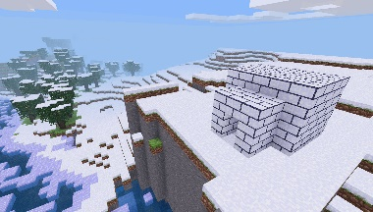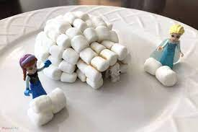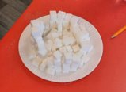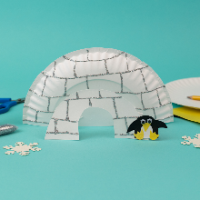
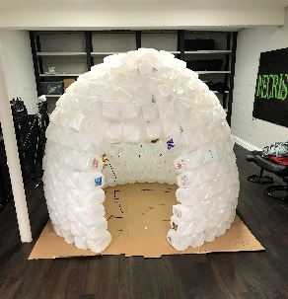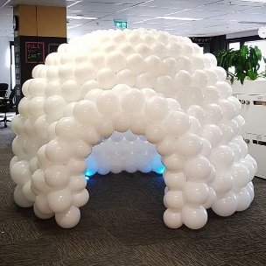
Remember to have lots of fun!

