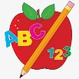 Primary 3 Homework
Week Beginning: 30th October 2023
Here is a guide to help you for this week. You can choose how to organise your tasks to suit what works for you.
Please bring book bags to school every day. They will be collected in on a Friday as there will not be any homework at the weekend.
 | Literacy | Numeracy
 | Spelling  Please complete 2 active and 2 written spelling activities for your words.  Activities list on blog.  Woody, Buzz Lightyear and Little Aliens  about around house hour side danger magic gentle energy germs gym stranger  Rex  blue best number other  glue true clue Sue persue | Click on the Learning Intention to play the games.  LI – To recap our number bonds.  https://www.topmarks.co.uk/maths-games/hit-the-button  LI – To add doubles and near doubles.  Choose your own game to play.  https://wordwall.net/en-us/community/doubles-near-doubles  LI – To bridge to 10s.  https://ictgames.com/mobilePage/monsterTruck/index.html  LI – To bridge over 10s.  https://ictgames.com/mobilePage/tugofwar/index.html
Reading
LI – We are learning to use expression.
We are learning to tell a text.
Retell your book to someone at home, using the retelling strategy.
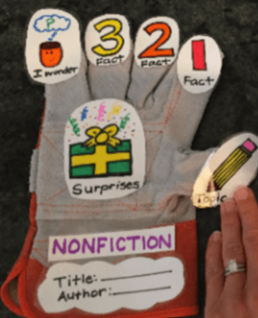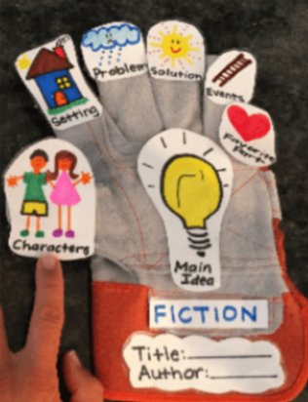
Woody
Stop That Dog!
Buzz Lightyear
What Makes You Laugh?
Little Aliens
The Mermaids and the Dolphin
Rex
Ding Dong

 | Polar Lands Topic Challenge – Due Friday 17th November
I can create a model or life size igloo using a variety of materials

We have been learning about the Arctic and the people and animals who live there. For your homework challenge, create your own igloo. You can draw, paint or use a range of different materials.
Here are some examples –
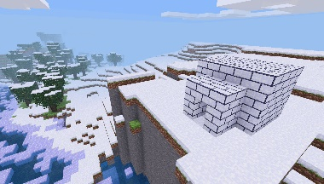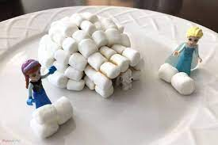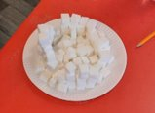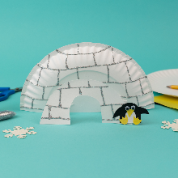
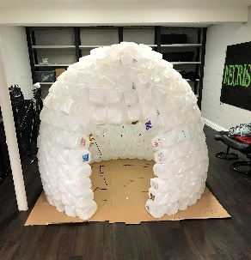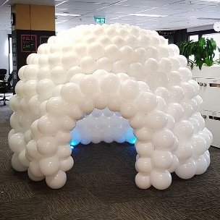
Remember to have lots of fun!

