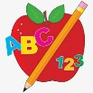 Primary 3 Homework
Week Beginning: 24th October 2023
Here is a guide to help you for this week. You can choose how to organise your tasks to suit what works for you.
Please bring book bags to school every day. They will be collected in on a Friday as there will not be any homework at the weekend.
 | Literacy | Numeracy
 | Spelling  Please complete 2 active and 2 written spelling activities for your words.  Woody, Buzz Lightyear and Little Aliens  own small something live give have dove leave believe retrieve starve relieve  Rex  play stay today away  speak clean steal team  low throw follow show | Click on the Learning Intention to play the games.  LI – To round numbers.  Choose your own rounding game.  https://www.mathnook.com/math/skill/roundinggames.php  LI – To recap our number bonds.  https://www.topmarks.co.uk/maths-games/hit-the-button  LI – To estimate an amount.  https://www.twinkl.co.uk/blog/fun-with-maths-estimating  - How many times can you write your name within one minute?  - Why not make maths sporty? Can you estimate how many star jumps you can do in one minute?  - Can you estimate how far you can run in one minute? Do you think you’ll run further or not in 30 seconds? Explain your answer.
Reading
LI – We are learning to use expression.
We are learning to retell a text.
Retell your book to someone at home, using the retelling strategy.
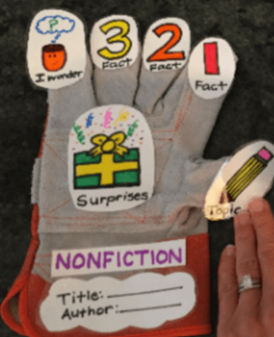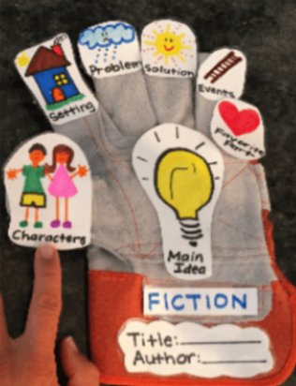
Woody
Thunderbirds Are Go: Skyhook
Buzz Lightyear
City Shapes and Other Poems
Little Aliens
Zeke Goes to Space School
Rex
Spring

 | Polar Lands Topic Challenge – Due Friday 17th November
I can create a model or life size igloo using a variety of materials

We have been learning about the Arctic and the people and animals who live there. For your homework challenge, create your own igloo. You can draw, paint or use a range of different materials.
Here are some examples –
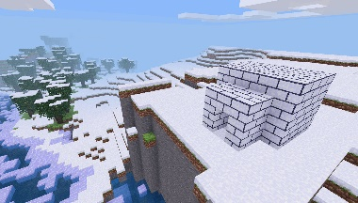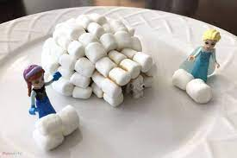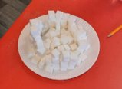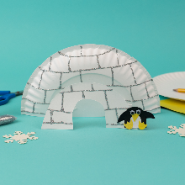
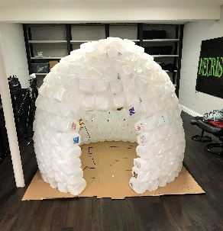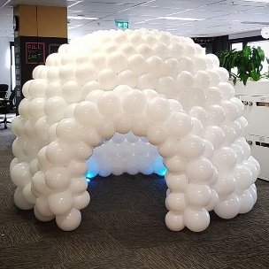
Remember to have lots of fun!

