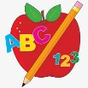 Primary 3 Homework
Week Beginning: 25th September 2023
Here is a guide to help you for this week. You can choose how to organise your tasks to suit what works for you.
Please bring book bags to school every day. They will be collected in on a Friday as there will not be any homework at the weekend. If you feel you want to continue some of the homework over the weekend please ask for your child’s book bag.
 | Literacy | Numeracy
 | Spelling  Please complete 2 active and 2 written spelling activities for your words.  Activities list on blog.  Woody, Buzz Lightyear and Little Aliens  match patch kitchen write  wrong wreck ready bread  weather walk swan water  this that rather  Rex  day away always today  tray play stay prayer  way | Click on the Learning Intention to play the games.  LI – We are learning to order numbers.  https://www.topmarks.co.uk/ordering-and-sequencing/coconut-ordering  LI – We are learning to identify more or less than a number.  Set your own number range and challenge yourself.  https://ictgames.com/mobilePage/countingCaterpillar/index.html
 | Reading  LI – We are learning to be fluent readers.  Woody  Can You Do This?  Buzz Lightyear  The Missing Masks  Little Aliens  Zip and Zap at the Zoo  Rex  King Pip and the Troll | Measure it  LI – We are learning to measure different lengths.  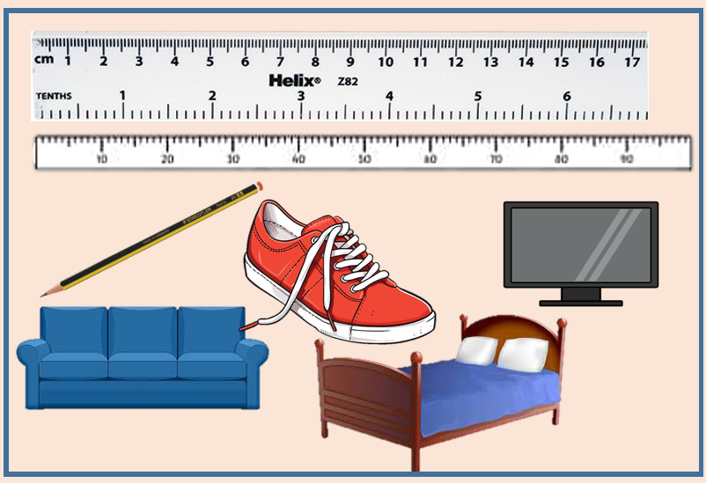  Measure objects around your house. Would you need different measuring equipment to measure different sizes?
Remember to have lots of fun!

