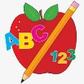 Primary 3 Homework
Week Beginning: 18th September 2023
Here is a guide to help you for this week. You can choose how to organise your tasks to suit what works for you.
Please bring book bags to school every day. They will be collected in on a Thursday as there will not be any homework at the weekend. If you feel you want to continue some of the homework over the weekend please ask for your child’s book bag.
 | Literacy | Numeracy
 | Spelling  Please complete 2 active and 2 written spelling activities for your words.  Activities list on blog.  Woody, Buzz Lightyear and Little Aliens  second fifteen five fourteen  was water wander warm  walk swallow swan wasp  Rex  said could her before  bucket brain stair boy  royal road quick queen | Click on the Learning Intention to play the games.  LI – We are learning to compare numbers.  Choose your own game and level.  https://www.mathnook.com/math/skill/comparisongames.php  Choose your own game and level.  https://wordwall.net/en-us/community/comparing-numbers-game  LI – We are learning to order numbers.  https://www.topmarks.co.uk/ordering-and-sequencing/coconut-ordering
 | Reading  LI – We are learning to be fluent readers.  Woody  King Julien and the Rain Dance / Can You Do This?  Buzz Lightyear  The Missing Masks  Little Aliens  Zip and Zap at the Zoo  Rex  King Pip and the Troll | Measure it  LI – We are learning to measure different lengths.  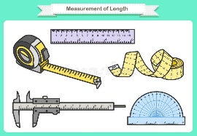  Measure the height of some plants in your local area.  Keep a record of the smallest and tallest plants you can find.
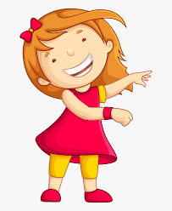Remember to have lots of fun!

